# TRAINING REPORT

UNDERTAKEN AT



## ENGINEERS INDIA LIMITED

IN

ITS DEPARTMENT

ON

Employee Database Management System

(EDMS)

Using React JS and ASP.NET Web API

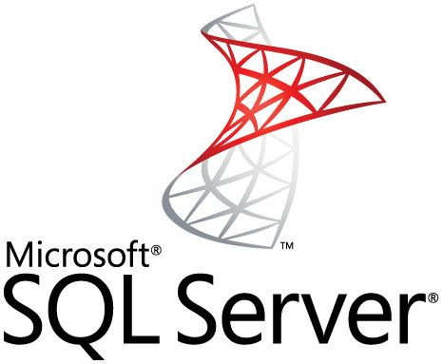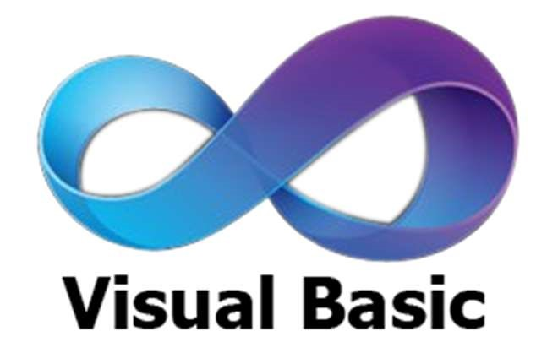

Under the guidance of:

Harsh Batra

Software Engineer

Information Technology Services Division, Engineers India Limited

Submitted By:

Aditi Gulati

Bachelor of Technology, Computer Science & Engineering

Indira Gandhi Delhi Technical University for Women

## Index

|  |  |  |
| --- | --- | --- |
| S. No. | Title | Page No. |
| 1. | Certificate | 3 |
| 2. | Acknowledgement | 4 |
| 3 | About Organization | 5-12 |
| 4. | About its department | 13-14 |
| 5. | Introduction | 15-17 |
| 6. | Tools Used | 18-28 |
| 7. | Basic Concepts | 29-34 |
| 8. | Project | 35-49 |
| 9. | Screenshots | 50-52 |
| 10. | Future Scope | 53 |
| 11. | References | 54 |

CERTIFICATE

This is to certify that Aditi Gulati student at Indira Gandhi Delhi Technical University for Women pursuing Bachelor of Technology in Computer Science & Engineering has successfully completed the training from 19th June 2023 to 31st July 2023.

During this training, she worked on “Employee Database Management System (EDMS)” in ITS under the guidance of Mr. Harsh Batra in Information Technology Services Division of Engineers India Limited, 1- Bhikaji Cama Place, New Delhi.

## **ACKNOWLEDGEMENT**

I express my gratitude to Mr. Niranjan Behera (DGM & Training Coordinator), –Information Technology Services (ITS) department Engineers India Limited, New Delhi for providing me the opportunity to work in such an esteemed organization which has helped in my growth in the IT Industry.

I would like to extend my sincere thanks to Mr. Harsh Batra (Mentor) who guided me a lot during the completion of this project. I have benefited so much from the constructive criticism and suggestions given to me by him during the project.

I am extremely thankful to Engineers India Limited (EIL) for providing me with the opportunity to avail the excellent facilities and infrastructure in completing my vocational training. I am also grateful to all the employees of EIL who have contributed in some way or the other in completing my Vocational Training successfully.

# About the Organization

ENGINEERS INDIA LIMITED

1.1 EIL

Engineers India Limited (EIL) was established on March 15, 1965, as a joint venture between the government of India and Bechtel Corporation of USA with the following prime objectives:

“To establish, provide, maintain and perform engineering and related technical and consultancy services for petroleum projects including but not limited to, petroleum refineries, oil field development, oil and gas pipelines, petrochemical facilities, chemical intermediaries and all other types of industrial projects”

In addition to petroleum refineries, EIL has diversified into other fields such as pipelines, chemicals and oil and gas processing, etc. EIL provides a complete range of project services in the fields and has emerged as South Asia’s leading design and engineering company.

EIL has under gone through more than 4000 assignments, 250 projects worth more than US$ 35 billion in installed cost, successfully completed and operating smoothly creating an array of satisfied clients and rising the turnover and profits. The major projects under taken by the company includes 30 Petroleum Projects, 6 Petroleum Complexes, 200 Offshore Platforms, 31 Oil and Gas Processing Projects, 25 Mining and Metallurgical Projects, 8 Fertilizers Projects, 31 Pipelines Projects and 11 Ports and Terminals. EIL has also worked abroad credibility in several countries of West Asia, North Africa, Europe and South-East Asia including Algeria, Abu Dhabi, Iran, Kuwait, Malaysia, Norway, Qatar, Saudi Arabia, Sri Lanka, UAE and Vietnam.

1.1.1 Vision Statement

“To become a globally Competitive EPC & Consultancy Organization”

1.1.2 Mission Statement

* To achieve international standards of excellence with a focus on customer satisfaction.
* To provide high quality, safe and energy-efficient services in Process Design, Engineering, Procurement, Construction with overall project Management in

Hydrocarbon, Metallurgy, Power and Ports & Terminals as well as Information Technology and other selected sectors of Industry.

* To achieve prominence in developing, adopting and assimilating state-of-the-art technology for competitive advantage.
* To maximize creation of wealth, value and satisfaction for stakeholders.
* To foster a culture of participation and innovation for employees' growth and contribution through a climate of fairness and transparency in operation.
* To acquire and provide technology and services through sustained Research & Development and linkage among Engineering Organizations, Equipment Manufacturers, Operating Companies and R&D Organizations to upgrade technologies on a continuous basis.
* To cultivate high standards of ethics and quality for a strong corporate identity and brand equity.
* To help enrich the quality of life of the community and preserve ecological balance and heritage through the services provided with a strong environmental conscience.

## 1.2 Historical Background

The foundation of the consultancy profession in India was laid soon after independence. The sixties saw the advent of major consultancy and engineering organization in the country with the setting up of a number of design and engineering organizations, in both private sector as well as public sector. Of these, Engineers India Ltd. Was the most prominent which was created in 1965 as a joint venture of the government of India (holding 51% shares) and Bechtel, a U.S. based company (holding 49% shares) to provide engineering and related services for petroleum and other industrial projects. In 1967, EIL became a wholly owned Government of India Undertaking.

Engineers India Limited has been serving the process industry providing a complete range of project services. Initially, it started with engineering work for petroleum refineries and diversified over the years, to add other fields of activity as well as other services. In response to the changing business environment, Engineers India went through several stages of development and has gradually evolved into an engineering company serving a wide range of industries including petroleum refineries, petrochemicals, oils and gas processing projects, pipelines, offshore platforms, fertilizers, chemical fibers and metallurgical industries providing a complete range of project service’s.

It provides consultancy in the following fields of operation:

* Petroleum
* Pipelines
* Oil and Gas Processing
* Fertilizers
* Power Ports & Terminals
* Petrochemicals
* Chemicals
* Metallurgy

1.2.1 Petroleum Refineries

Engineers India Limited has provided its services for over a dozen projects with a combined refining capacity of 23 million tones/annum (460,000 bbl./day) and is working on several other projects with a total refining capacity of over 25 million tones/annum (500,000 bbls/day). The projects include grassroots as well as expansion revamp projects of all refining companies in India apart from refinery projects abroad. EIL has developed skills to such an extent that barring the process design of a few licensed units; EIL can execute complete petroleum refinery projects on its own. In addition to technologies for the main refinery units, EIL also has technologies for lube refinery complexes.

1.2.2 Fertilizers

Engineers India Limited provides complete services starting with feasibility study up to commissioning for fertilizer plants based on gas, naphtha and fuel oil. EIL has worked with renowned licensors/contractors on various assignments for ammonia, urea and phosphates fertilizer plants, in India and abroad.

1.2.3 Pipelines

Engineers India has the capability to plan and execute long distance cross country and submarine pipelines for transportation of crude oil, petroleum products, gases, two phase fluids and slurries. It provides services such as conceptual scheme, feasibility study, on site investigations and route survey, cathodic protection and telemetry, telecommunication and tele supervisory control for pipeline projects besides other project services such as design and engineering, procurement, construction supervision and project management.

1.2.4 Oil and Gas processing

Engineers India Limited has expertise for Crude Oil processing plants such as:

* Crude Gathering Stations
* Multistage Separation
* Crude Desalting
* Dehydration and Heavy Oil/Sour Oil Processing.

It also has capabilities for implementing Gas Conditioning and Processing Plants including Gas Collection Systems, Compressor Stations, and Solid/Liquid Desiccant Dehydration, Dew point Depression, Impurities and Acid gases removal and Cryogenic Natural Gas Liquids recovery such as LPG and Ethane / Propane recovery. It has handled a number of such plants for the Oil and Natural Gas Corporation Limited and Gas Authority of India Ltd. It has also provided consultancy for LPG and LNG projects of Sonatrach in Algeria.

1.2.5 Power

In the field of power, EIL has undertaken assignments for captive power plants in large process plants such as petroleum refineries, petrochemical complexes, etc. and has undertaken feasibility studies for refinery residue based power projects.

EIL has association with: -Foster Wheeler Italiana for Residue Based Power Plants Kema, Netherlands for Renovation & Modernization and Life extension studies for Existing Power Plants.

1.2.6 Ports and terminals

The Ports & Terminals Division of EIL takes up projects such as jetties, SPMs, MBMs at waterfronts or near to shore and related submarine pipelines with onshore facilities like terminals, etc. The areas of operation include:

* Master Plans for Ports
* Technical assistance in Marine Surveys
* Port Facilities/Jetties
* Inland Terminals for receipt, storage and dispatch of liquid cargo in both pressurized and cryogenic conditions

Offshore Handling Facilities including:

* Single Buoy Moorings ✓ Multi Buoy Moorings
* Submarine Pipelines

Port based Terminals for receipt, storage and dispatch of:

* Hydrocarbon products
* Chemicals & Petrochemicals
* Dry cargo both in bulk and bagged condition

1.2.7 Ocean Engineering

Engineers India's Ocean Engineering Division was formed in 1971 and has been involved in the development of India's offshore oil and gas fields since then. Engineers India has wide capabilities for providing full range of services needed to plan, design, engineer, construct and commission ocean engineering projects such as oil and gas platforms, offshore oil terminals, oil and fertilizer loading berths, intake structures, SBMs, offshore lighthouses, floating pump houses and fabrication yards.

1.2.8 Chemical

EIL has expertise for chemical plants such as membrane cell technology based caustic soda plants, soda ash, vaccine, insecticides etc., for which complete range of services can be offered. 1.2.9 Metallurgy

In the field of metallurgy, EIL can render a comprehensive range of consultancy and engineering services for zinc, lead, aluminum, copper, cadmium, silver, nickel, magnesium, titanium, etc. and also for sponge iron. In addition, EIL can provide services for mine development and beneficiation plants. The specialized services include Studies for Scaling up of Pilot Plant to Industrial Plant, Process & Licensor selection, Optimization of the process parameters, Energy Conservation etc. The areas of operation encompass:

* Exploration data review, Geostatistical Ore reserve estimation and Ore Body modeling.
* Planning and Design of Open Pit Mines, Pit Optimization Studies and Quality control.
* Environmental studies for Mines.
* Ore handling, storage and long distance conveying.
* Design of Mineral Processing Plant and simulation & Optimization of crushing, grinding and beneficiation circuits including conventional as well as column flotation cells.
* Hydrometallurgical plants such as alumina refineries and lead smelters.
* Pyro/electro metallurgical plants such as primary Aluminum and lead smelters. Design of environment friendly tailings disposal/ stacking systems.

## 1.3 Services Offered by EIL

1.3.1 Feasibility Studies

EIL's experience in a variety of fields is available to clients for expansion or diversification of their activities. Services offered include preliminary studies to examine the viability of project, market potential of products, techno-economic evaluation, capital and operating cost estimates etc 1.3.2 Pre-feasibility Studies

To examine the viability of the project, market potential of products,techno-economic evaluation, capital & operating cost estimates etc.

1.3.3 Detailed Feasibility Studies

EIL also undertakes detailed feasibility studies to form the final cost of the project. These detailed feasibility reports are also bankable to ensure that financial institutions can use them for lending purposes.

EIL's project management services comprise direction and coordination of the activities leading to the completion of a job in accordance with terms of the contract, in compliance with the job schedule and to the satisfaction of the client. The efforts of various agencies such as licensors, subcontractors & EIL's different departments are brought together in a logical pattern to result in fruitful culmination of the project.

1.3.4 Heat and Mass Transfer Equipment Design

Heat and Mass Transfer Division (HTD) specializes in design and revamp of heat & mass transfer equipment & related process package systems as part of overall EIL project or as individual direct assignment to meet the requirement of new as well as existing plants. Experience of HMTD in design and revamp of heat and mass transfer equipment system is unparalleled.

The experienced manpower resources in HMTD carry out a wide range of services for the following heat & mass transfer equipment, process and energy systems:

* Fired Heaters & Air Preheating System
* Heat Exchangers
* Trays
* Packing & Packed Tower Internals
* Gas Dehydration System and Oil - Water - Gas Separators
* Vacuum Ejector System, Process Waste Heat & CO Boiler and Incinerators ✓ Deaerators
* De salters

1.3.5 Detailed Engineering

The process design package is converted into detailed engineering drawings and documents by specialist civil, structural, mechanical, and electrical & instrumentation engineers, Computer aided design techniques are extensively used as design aides to help develop optimum layout & design to assure maximum construction, operational & maintenance convenience.

Detailed engineering leads to identification & specification of equipment and materials for procurement & needs of construction activities at site.

Specialized Services are provided in the fields of static & dynamic analysis of equipment, structures, geotechnical engineering, rotating equipment & troubleshooting.

1.3.6 Project Management Consultancy

The experience gained in the implementation of complex integrated projects has enabled Engineers India to undertake the role of Project Management Consultant. As Project Management Consultant, EIL provides management services required for smooth implementation of a complex project. It takes full responsibility for the overall co-ordination and integration of functioning of all agencies engaged in the implementation of the entire project and ensures the completion on schedule and within the budgeted cost.

EIL's scope as Project Management Consultant broadly covers the following:

* Conceptualization of the Project ✓ Technology Selection.
* Developing Design Basis.
* Selection of EPC Contractors.
* Project Management including supervision, co-ordination, planning and scheduling services, etc.
* Quality Assurance at all stages of the project implementation, viz. process design, detailed engineering, procurement and construction.
* Assistance in inspection, testing, pre-commissioning and commissioning of facilities.

1.3.7 Environmental Services

EIL offers extensive services in the field of environmental engineering such as Environment impact assessment, Waste water treatment, Water treatment, Solids and hazardous waste management, Environmental audits, Resource recovery and recycle, Pollution prevention and Waste minimization, etc. These services are provided for Petroleum Refineries,

Petrochemical Plants, Pipeline Projects, Oil/Gas Installations and Chemical Ports, Terminals, SBM's and Jetties and Non-ferrous Metallurgical projects. EIL's close familiarity with the technologies involved in the process industry gives it a unique advantage for undertaking environment-related assignments.

1.3.8 Planning and Scheduling

EIL ensures effective and timely execution of projects through detailed planning and micro scheduling along with continuous monitoring. For this purpose, the industry standard PRIMAVERA software is used for computerized network analysis (PERT/CPM). Other software packages such as HOST, CPS, MCS, and COSMAS etc. are used for home office scheduling, construction, and planning and material control. Detailed schedules for engineering, ordering, manufacturing, delivery, tendering and construction are developed. These schedules are reviewed and updated and project completion outlook analyzed and corrective actions taken regularly. In addition, physical progress of the project is measured and reported through a well-designed reporting system, which enables complete evaluation of project performance.

1.3.9 Construction Management

EIL's Construction Division provides total construction management services at site including selection of construction contractors, warehouse management, quality control/quality assurance, process monitoring & scheduling, review of heavy erection schemes, safety etc. Depending on client's need, EIL takes total site responsibility from survey & soil investigation to mechanical completion & assistance in commissioning. Use of modern construction techniques, innovative construction procedures, emphasis on QA/QC are some of the hallmarks based on which it has been possible for EIL to reduce construction time of projects yet providing work of highest quality. 1.3.10 Cost Engineering

EIL’s cost engineering services help the project management team in exercising practically online control of the costs vis-à-vis project execution budgets through application of latest techniques of Project Cost Management. Large dynamic database & in-house developed programs operating on PC platform are used in estimating costs of work packages prior to their award. A periodic 'Cost-to-Completion' projection is made through in-house developed program "CEMOS" software to assist the Project Manager & Owner in taking timely decisions & actions. The cost engineering systems employed are kept updated through the latest developments in cost management techniques as also through experience gained while working on international projects.

1.3.11 Procurement

EIL offers comprehensive procurement services through a highly professional purchase team, effective monitoring and expediting group, a well experienced and qualified multi-disciplinary inspection force and a specialist group for route survey and planning for multi modal movement of over dimensional consignments.

Following comprehensive procurement services are provided ✓ Vendor identification, evaluation & enlistment.

* Entire purchase activity, floating of enquiry to placement of order.
* Order placement
* Progress monitoring & Expediting
* Inspection
* Transportation planning & control
* Safety certification under Static & Mobile Pressure Vessels (SMPV) rules of the Chief Controller of Explosives
* Statutory inspection in Europe & Japan under Indian Boiler Regulations.

A databank, providing significant information on capable vendors all over the world, is maintained and constantly updated. EIL's twelve inspection offices in the country provide competitive and prompt services in India. Overseas offices in Tokyo & London offer procurement/inspection services outside India in the Far East & Europe.

1.3.12 Commissioning and Plant Start up

EIL's Commissioning team associates itself with the project right from the process design stage. It reviews process & engineering design documents especially with respect to operability & safety. The team also prepares operation manuals providing instructions for plant start-up, shutdown & handling various emergencies. It provides guidelines and supervises pre commissioning & commissioning activities at site. EIL's responsibility continues till production of specification products has been established to the full satisfaction of the customers. The team assists process department in conducting performance guarantee tests in order to establish plant operation at design throughputs with product of specified quality. EIL also provides technical guidance to customers in the area of troubleshooting.

# About the Department

1.4 Information Technology Services Division

1.4.1 Introduction

Information Technology Services (ITS), a division of EIL has a well-knit team of over 100 multidisciplinary professionals who are well qualified and experienced in providing software related and networking design services. Over the last 25 years, ITS has developed a large number of integrated software packages for use within EIL in the areas of process design, engineering, procurement, project management and construction. This experience along with the domain knowledge in various functional disciplines has given an edge to ITS for providing value added services to its clients in Oil Industry in particular and others in general. ITS has spearheaded the task of making EIL a leader both in terms of software usage and having state-of-the-art computing facilities and communication infrastructure leading to enterprise connectivity.

IT'S over the years has executed a number of offshore and onshore software development assignments for clients in India and abroad. The application areas covered are engineering solutions, business applications (viz. materials management, maintenance management, financial accounting, and personnel management), integrated plant information systems, intranet development, operations research etc.

An overview of range of services along with assignments handled and clientele highlighting EIL's IT experience is enumerated hereafter.

1.4.2 Range of IT Services

Preparation of a Master Plan and Its Implementation

EIL has executed a number of assignments in the areas of configuration assessment, evaluation, selection and acceptance testing of computer and communication systems and implementation for clients like:

* Gas Authority of India Ltd.
* Bongaigaon Refinery & Petrochemicals Ltd.
* Electricity Boards etc.

EIL has also executed studies involving preparation of Refinery wide Master Plans taking into consideration the integration of DCS, process functions & management information systems for clients like:

* Indian Oil Corporation,
* Cochin Refineries
* Bharat Petroleum Corporation Limited.

Customized Software Development for Engineering and Business Application

EIL has undertaken a number of customized software development and implementation assignments in the following application areas:

Implementation of Plant Design Systems on PDS & PDMS platforms for Aker Corporation, Norway & PIDEC in Iran.

On-line Integrated Materials Information System covering activities like indents, purchase, stores issues/receipts, material accounting for operating plants namely Indian Petrochemicals Corporation Ltd., Oil & Natural Gas Corporation, Bongaigaon Refinery & Petrochemicals Ltd.

Computer Aided Maintenance Information System covering preventive & predictive maintenance, work order, maintenance cost & breakdown history for BIPC, Iran. Financial Management Systems including books, ledgers (main & subsidiary), balance sheet, & asset account for major electrical utilities.

Plant Database Creation & Document Management

EIL has developed software, which provides for value added transfer of integrated plant information system from EPC contractor to the client on electronic media. This software has been implemented for Panipat Refinery Project and many other jobs are in advanced stage of finalization.

Internet Application Development and Implementation

EIL has developed expertise in development of JAVA & HTML based applications for implementation on Intranet. In addition to having Intranet for in-house needs, an assignment has recently been completed for Gas Authority of India Ltd.

Enterprise Recourse Planning (ERP) Implementation

EIL has trained its software specialists and domain experts on the implementation of ERP solutions. Currently a number of jobs are planned to be taken for Oil Industry in India in association with our business partners M/s RAMCO for their ERP product, namely MARSHAL.

Operations Research (Linear Programming, Transport Models and Queuing)

EIL has executed a number of assignments involving OR techniques for the Ministry of Petroleum, Govt. of India and also a study based on queuing model for a port in Malaysia. Major investment decisions have been taken by the clients based on these optimization studies.

# INTRODUCTION

## ASP.NET

It is a web development platform, which provides a programming model, a

comprehensive software infrastructure and various services required to build up robust web applications for PC, as well as mobile devices.

ASP.NET works on top of the HTTP protocol, and uses the HTTP commands and policies to set a browser-to-server bilateral communication and cooperation.

ASP.NET is a part of Microsoft .Net platform. ASP.NET applications are compiled codes, written using the extensible and reusable components or objects present in .Net framework. These codes can use the entire hierarchy of classes in .Net framework.

The ASP.NET application codes can be written in any of the following languages:

* C#
* Visual Basic.Net
* Jscript
* J#

ASP.NET is used to produce interactive, data-driven web applications over the internet. It consists of a large number of controls such as text boxes, buttons, and labels for assembling, configuring, and manipulating code to create HTML pages.

The key development tool for building ASP.NET applications and front ends is Visual Studio. In this project, we work with Visual Studio 2013.

Visual Studio is an integrated development environment for writing, compiling, and debugging the code. It provides a complete set of development tools for building ASP.NET web applications, web services, desktop applications, and mobile

applications.

A typical ASP.NET application consists of many items: the web content files (.aspx), source files (.cs files), assemblies (.dll and .exe files), data source files (.mdb files), references, icons, user controls and miscellaneous other files and folders. All these files that make up the website are contained in a Solution.

Solutions may contain one or more projects. A project contains content files, source files, and other files like data sources and image files. Generally, the contents of a project are compiled into an assembly as an executable file (.exe) or a dynamic link

library (.dll) file.

Typically a project contains the following content files:

* Page file (.aspx)
* User control (.ascx)
* Web service (.asmx)
* Master page (.master)
* Site map (.sitemap)
* Website configuration file (.config)

VB.NET

Visual Basic .NET (VB.NET) is an object-oriented computer programming language implemented on the .NET Framework. Although it is an evolution of classic Visual Basic language, it is not backwards-compatible with VB6, and any code written in the old version does not compile under VB.NET.

Like all other .NET languages, VB.NET has complete support for object-oriented concepts. Everything in VB.NET is an object, including all of the primitive types (Short, Integer, Long, String, Boolean, etc.) and user-defined types, events, and even assemblies. All objects inherits from the base class Object.

VB.NET is implemented by Microsoft's .NET framework. Therefore, it has full access to all the libraries in the .Net Framework. It's also possible to run VB.NET programs on Mono, the open-source alternative to .NET, not only under Windows, but even Linux or Mac OS.

The following reasons make VB.Net a widely used professional language:

* Modern, general purpose.
* Object oriented.
* Component oriented.
* Easy to learn.
* Structured language.
* It produces efficient programs.
* It can be compiled on a variety of computer platforms.
* Part of .Net Framework.

Strong Programming Features VB.Net

VB.Net has numerous strong programming features that make it endearing to multitude of programmers worldwide. Let us mention some of these features:

* Boolean Conditions
* Automatic Garbage Collection
* Standard Library
* Assembly Versioning
* Properties and Events
* Delegates and Events Management
* Easy-to-use Generics
* Indexers
* Conditional Compilation
* Simple Multithreading

TOOLS USED:

1. Microsoft Visual Studio 2019
2. ASP.NET Web API
3. ReactJS
4. SQL Server
5. React Strap
6. Bootstrap

## 1. Visual Studio .NET :-

Code editor Visual Studio, like any other IDE, includes a code editor that supports syntax, highlighting and code completion using IntelliSense for not only variables, functions and methods but also language constructs like loops, query, sheets and JavaScript when developing websites and web applications. Autocomplete suggestions are popped up in a modeless list box overlaid on top of the code editor. The code editor issued for all supported languages.

2. ASP.NET Web API :-

In computer programming, an application programming interface (API) is a set of subroutine definitions, protocols, and tools for building software and applications.

To put it in simple terms, API is some kind of interface which has a set of functions that allow programmers to access specific features or data of an application, operating system or other services.

Web API as the name suggests, is an API over the web which can be accessed using HTTP protocol. It is a concept and not a technology. We can build Web API using different technologies such as Java, .NET etc. For example, Twitter's REST APIs provide programmatic access to read and write data using which we can integrate twitter's capabilities into our own application.

The ASP.NET Web API is an extensible framework for building HTTP based services that can be accessed in different applications on different platforms such as web, windows, mobile etc. It works more or less the same way as ASP.NET MVC web application except that it sends data as a response instead of html view. It is like a webservice or WCF service but the exception is that it only supports HTTP protocol.

[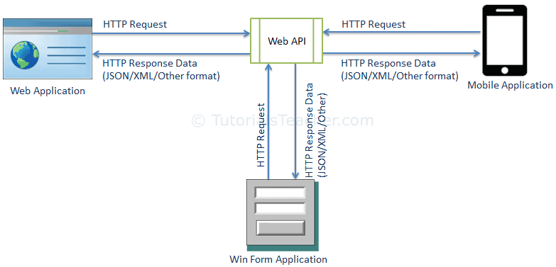](https://www.tutorialsteacher.com/Content/images/webapi/webapi-overview.png)Web API

## ASP.NET Web API Characteristics

1. ASP.NET Web API is an ideal platform for building RESTful services.
2. ASP.NET Web API is built on top of ASP.NET and supports ASP.NET request/response pipeline
3. ASP.NET Web API maps HTTP verbs to method names.
4. ASP.NET Web API supports different formats of response data. Built-in support for JSON, XML, BSON format.
5. ASP.NET Web API can be hosted in IIS, Self-hosted or other web server that supports .NET 4.0+.
6. ASP.NET Web API framework includes new HttpClient to communicate with Web API server. HttpClient can be used in ASP.MVC server side, Windows Form application, Console application or other apps.

## 3. .NET Framework:-

.Net Component:-

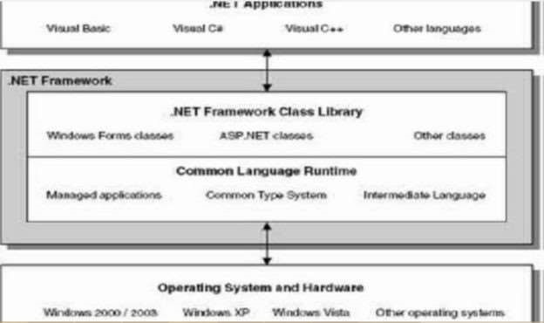

.NET Framework is divided into two main components: the .NET Framework Class Library and the Common language Runtime.

Common Language Runtime

The Common Language Runtime is the execution engine for .NET Framework applications’ provides a number of services, including the following :

·

⬤ Code management (loading and execution) o Application memory isolation o

Verification of type safety o Conversion of IL to native code Access to metadata

(enhanced type information) Managing memory for managed objects Common Type System:-

Defines how types are declared, used, and managed in the runtime, and is also an important part of the runtime's support for cross-language integration. The common type system performs the following functions:

·

⬤ Establishes a framework that helps enable cross-language integration, type safety, and high performance code execution.

·

⬤ Provides an object-oriented model that supports the complete implementation of many programming languages. Defines rules that languages must follow, which helps ensure that objects written in different languages can interact with each other .

.NET Framework Class Library Overview:-

The .NET Framework includes classes, interfaces, and value types that expedite and optimize the development process and provide access to system functionality. To facilitate interoperability between languages, the .NET The .NET Framework includes types that perform the following functions:

⬤ Represent base data types and exceptions. Encapsulate data structures.

⬤ Perform I/O, Invoke .NET Framework security checks.

Architecture Design

THE ARCHITECTURE of ADO.NET:

To access the database, the first action you take consists of establishing a connection with the database. To support this, the System.Data.OleDb namespace OleDbConnection class.

Architecture Design

THE ARCHITECTURE of ADO.NET:

To access the database, the first action you take consists of establishing a connection with the database. To support this, the System.Data.OleDb namespace OleDbConnection class.

⬤ Dataset:-the dataset is disconnected in memory representation data. it can be consider as local copy of the relevant portion of the database. The dataset is persists in memory and the data in it can be manipulated and updated independent of the database. When the use of this dataset is finished changes can be made back to the central database for updating the data in dataset can be loaded from any valid data source like oracle.

⬤ Data provider:- the data provider is responsible for providing and maintaining the connection to the database a data provider is a set of related components that work together to provide data in an efficient and performance driver manner Introduction of OLE DB:- OLE DB is a COM based object model used for access to various relational data sources as well as structured, not relational data (such as folders in an email store, or a file system). This ability to access both relational and structured data is one of the major features that set OLE DB apart from ODBC.

⬤ .Connectionstring:- Connection string has information required to connect to a database. It generally consists of information of provider, drivers, data source, user name, password etc.

⬤ The data source:- After specifying the provider, an important factor is the name of the database you want to connect to. This information is referred to as the data source. If you are creating a connection string, to specify the data source, assign the complete path of the database to the Data Source factor.

If you had declared an OleDbConnection variable using the other constructor, to specify the data source, you can include its section in the connection String argument of the constructor.

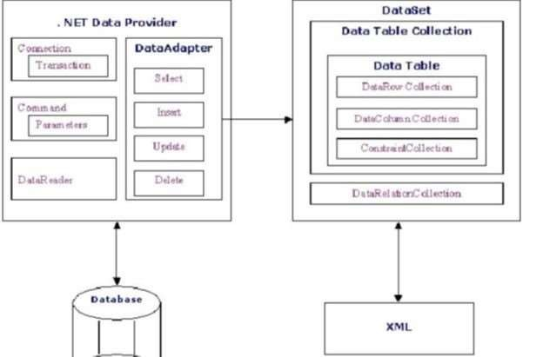

Figure represents System Requirement Specifications

## 4. ReactJS

React is a JavaScript library that forces you to think in terms of components. This model of thinking fits user interfaces well. Depending on your background it might feel alien at first. You will have to think very carefully about the concept of state and where it belongs.

Because **state management** is a difficult problem, a variety of solutions have appeared. In this book, we'll start by managing state ourselves and then push it to a Flux implementation known as Alt. There are also implementations available for several other alternatives, such as Redux, MobX, and Cerebral.

React is pragmatic in the sense that it contains a set of escape hatches. If the React model doesn't work for you, it is still possible to revert back to something lower level. For instance, there are hooks that can be used to wrap older logic that relies on the DOM. This breaks the abstraction and ties your code to a specific environment, but sometimes that's the pragmatic thing to do.

## Virtual DOM

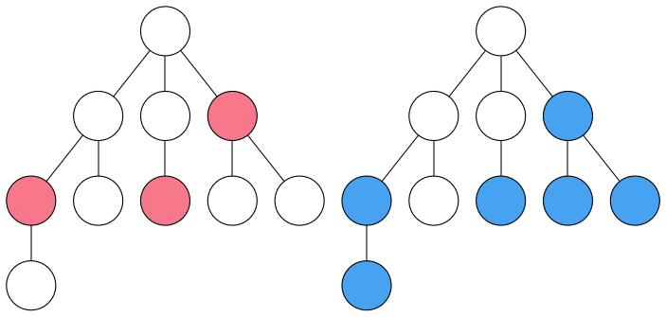Virtual DOM

One of the fundamental problems of programming is how to deal with state. Suppose you are developing a user interface and want to show the same data in multiple places. How do you make sure the data is consistent?

Historically we have mixed the concerns of the DOM and state and tried to manage it there. React solves this problem in a different way. It introduced the concept of the **Virtual DOM** to the masses.

Virtual DOM exists on top of the actual DOM, or some other render target. It solves the state manipulation problem in its own way. Whenever changes are made to it, it figures out the best way to batch the changes to the underlying DOM structure. It is able to propagate changes across its virtual tree as in the image above.

**Features of React**

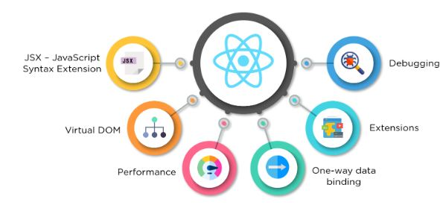

**Fig:**React Features

### **JSX - JavaScript Syntax Extension**

JSX is a syntax extension to JavaScript. It is used with React to describe what the user interface should look like. By using JSX, we can write HTML structures in the same file that contains JavaScript code. This makes the code easier to understand and debug, as it avoids the usage of complex JavaScript DOM structures.

## 5. SQL Server

SQL Server is a relational database management system, or RDBMS, developed and marketed by Microsoft.

Similar to other RDBMS software, SQL Server is built on top of SQL, a standard programming language for interacting with the relational databases. SQL server is tied to Transact-SQL, or T-SQL, the Microsoft’s implementation of SQL that adds a set of proprietary programming constructs.

SQL Server works exclusively on Windows environment for more than 20 years. In 2016, Microsoft made it available on Linux. SQL Server 2017 became generally available in October 2016 that ran on both Windows and Linux.

## **SQL Server Architecture**

The following diagram illustrates the architecture of the SQL Server:

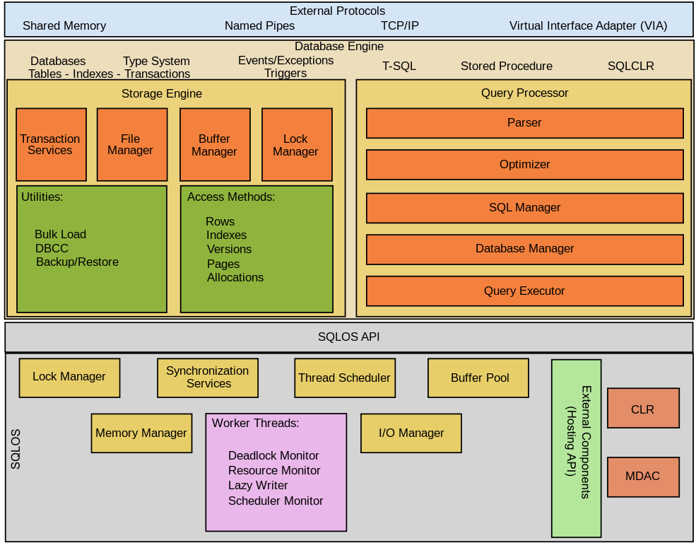

SQL Server consists of two main components:

1. Database Engine
2. SQLOS

### **Database Engine**

The core component of the SQL Server is the Database Engine. The Database Engine consists of a relational engine that processes queries and a storage engine that manages database files, pages, pages, index, etc. The database objects such as stored procedures, views, and triggers are also created and executed by the Database Engine.

#### **Relational Engine**

The Relational Engine contains the components that determine the best way to execute a query. The relational engine is also known as the query processor.

The relational engine requests data from the storage engine based on the input query and processed the results.

Some tasks of the relational engine include querying processing, memory management, thread and task management, buffer management, and distributed query processing.

#### **Storage Engine**

The storage engine is in charge of storage and retrieval of data from the storage systems such as disks and SAN.

### **SQLOS**

Under the relational engine and storage engine is the SQL Server Operating System or SQLOS.

SQLOS provides many operating system services such as memory and I/O management. Other services include exception handling and synchronization services.

## **SQL Server Services and Tools**

Microsoft provides both data management and business intelligence (BI) tools and services together with SQL Server.

For data management, SQL Server includes SQL Server Integration Services (SSIS), SQL Server Data Quality Services, and SQL Server Master Data Services. To develop databases, SQL Server provides SQL Server Data tools; and to manage, deploy, and monitor databases SQL Server has SQL Server Management Studio (SSMS).

For data analysis, SQL Server offers SQL Server Analysis Services (SSAS). SQL Server Reporting Services (SSRS) provides reports and visualization of data. The Machine Learning Services technology appeared first in SQL Server 2016 which was renamed from the R Services.

## **SQL Server Editions**

SQL Server has four primary editions that have different bundled services and tools. Two editions are available free of charge:

SQL Server Developer edition for use in database development and testing.

SQL Server Expression for small databases with the size up to 10 GB of disk storage capacity.

For larger and more critical applications, SQL Server offers the Enterprise edition that includes all SQL server’s features.

SQL Server Standard Edition has partial feature sets of the Enterprise Edition and limits on the Server regarding the numbers of processor core and memory that can be configured.

For the detailed information on the SQL Editions, check it out the available Server 2017 Editions.

In this tutorial, you have a brief overview of the SQL Servers including its architecture, services, tools, and editions.

## 6. Bootstrap

Bootstrap is a free and open-source tool collection for creating responsive websites and web applications. It is the most popular HTML, CSS, and JavaScript framework for developing responsive, mobile-first websites. It solves many problems which we had once, one of which is the cross-browser compatibility issue. Nowadays, the websites are perfect for all the browsers (IE, Firefox, and Chrome) and for all sizes of screens (Desktop, Tablets, Phablets, and Phones). All thanks to Bootstrap developers -Mark Otto and Jacob Thornton of Twitter, though it was later declared to be an open-source project.

## 7. Bootstrap

**Reactstrap**is a bootstrap-based react UI library that is used to make good-looking webpages with its seamless and easy-to-use component.

**Properties:**

* **Tag:**In ReactStrap Media Component, Tag is a property that is used to set the tag in the component. It takes string and function values.
* **className:**In ReactStrap Media Component className define the class name of the component. With the help of className, you can add the styling using CSS.
* **heading:**In ReactStrap Media Component heading is the property in reactStrap is used to set the heading in the text. It takes a boolean value as the default argument.
* **middle**: In the reactStrap, the middle property is used to set the middle alignment between the two objects. It takes a boolean value.
* **fluid:** In ReactStrap Media Component fluid is applies .container-fluid class and if string then it applies .container-{breakpoint} class.
* **block:** In ReactStrap Media Component block props are used to indicate whether the block should have a block style or not.
* **color:** The color props in the reactStrap are used to set the color of the element in the component.
* **body:** The bodyproperties in the media component are used to set the body of the element. By default, it takes a boolean value.
* **bottom:**The bottom properties are used to fix the position in the bottom of the components. It should be true or false, it takes a boolean value.
* **children:**childrenproperties are used to set the children of the element in components. It takes a node value.
* **heading:** heading properties is used to set the heading of the element, by default it takes a boolean value.
* **left:**left properties are used toset the alignment of the element on the left side of the component, it takes a boolean value .

BASIC CONCEPTS AVAILABLE IN ASP.NET WEB API:

Web API is an application programming interface (API) that is used to enable communication or interaction with software components with each other. ASP.NET Web API is a framework that makes it easy to build HTTP Service that reaches a broad range of clients, including browsers and mobile devices. Using ASP.NET, web API can enable communicating by different devices from the same database.

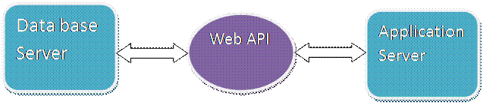

## **Uses of Web API**

* It is used to access service data in web applications as well as many mobile apps and other external devices.
* It is used to create RESTful web services. REST stands for Representational State Transfer, which is an architectural style for networked hypermedia applications.
* It is primarily used to build Web Services that are lightweight, maintainable, and scalable, and support limited bandwidth.
* It is used to create a simple HTTP Web Service. It supports XML, JSON, and other data formats.

Web API using ASP.NET MVC, C#, and Visual Studio.

## **Step 1. Create ASP.NET Web Application in Visual Studio**

Open Visual Studio and open a new project. Select Visual C# >> Web >> ASP.NET Web Application. After selecting all, give the project name and click OK.

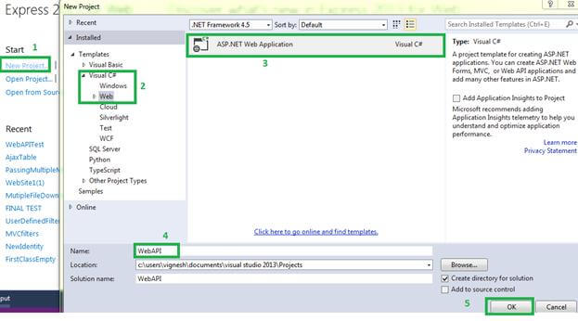

## **Step 2. Select Web API Template**

Select Web API in the template window. After selecting Web API, we can see some messages on the right side in the template window. Now, click the OK button.

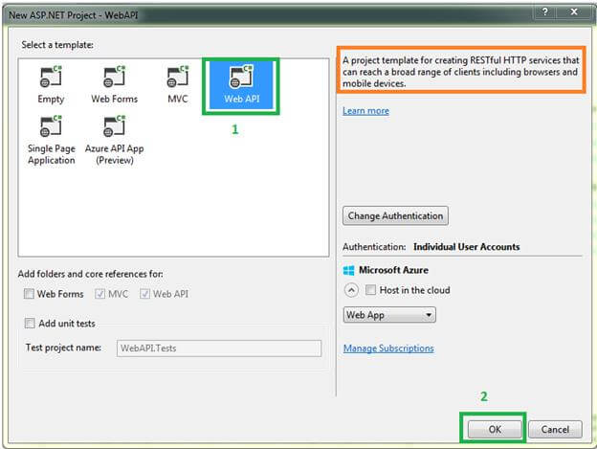

## **Step 3. Review Project Files**

Now, you're in Visual Studio with project files listed under the project name. We can see in the Solution Explorer on the right side with all the important files and folders like MVC. The

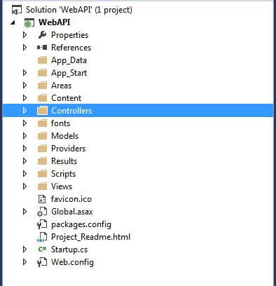

## **Step 4. Add a Controller**

Now, go to Controller and expand the controller. Now, we can see “ValuesController.cs”. It is the main class for Web API. This controller is created by default. If we need a new controller or one with a different name, we can create that in the following way.

Select and right-click Controllers >>Add >> Controller, just like the below screen.

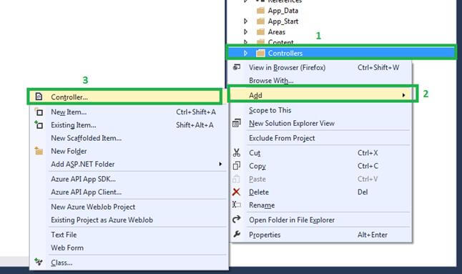

Select “Web API 2 Controller - Empty” and click the "Add" button from the "Add Scaffold" window.

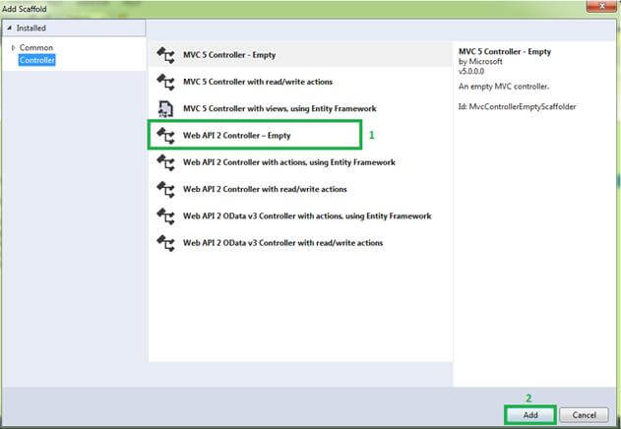

Here is what the screen looks like.

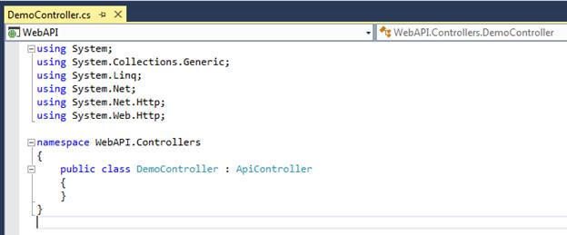

In Web API, the Controller is inherited by the “ApiController” abstract class. It is very important and basic for Web APIs. The namespace for this class is “System.Web.Http”.

## **Step 5. Add Controller Method**

Now, create a simple method in Controller, build the application, and run it finally. In web API, we use the method name as “Get ()". We can use any other method name. Let's write the below code in the Demo controller.

1. using System.Net;
2. using System.Net.Http;
3. using System.Web.Http;
4. namespace WebAPI.Controllers {
5. **public** **class** DemoController: ApiController {
6. **public** string Get() {
7. **return** "Welcome To Web API";
8. }
9. **public** List < string > Get(**int** Id) {
10. **return** **new** List < string > {
11. "Data1",
12. "Data2"
13. };
14. }
15. }
16. }

## **URL Format to run Web API**

We need to run the Web API “api/Controller_Name” URL format. For example, in MVC we define URL format using “RouteConfig” class and “RegisterRoutes” static methods. The same for Web API; we are using the “WebApiConfig” and “Register” static method. Go to the “Global.aspx” file we can see in detail.

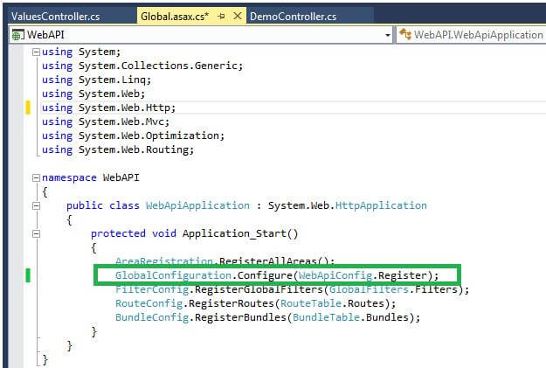

We define the Web API URL format using “GlobalConfiguration” and “Configure” static method. We are passing the “Register” method from the “WebApiConfig” class as an argument into the “Configure” method. If we go to the “WebApiConfig” class, we can see Web API routes.

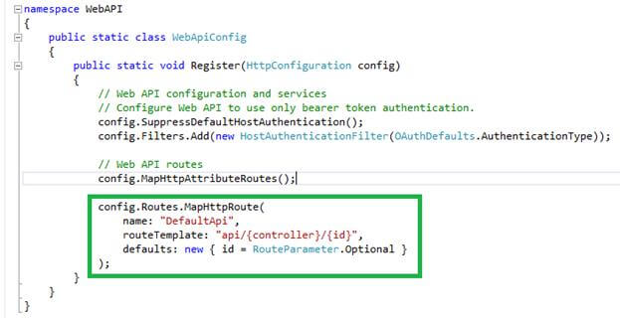

## **Step 6**

Now, build your project and run the above-mentioned URL format. Our Controller name is “Demo”, so we will run the following URL : “http://localhost:53027/api/Demo”.

Web API has returned a result in XML or JSON format. Our output looks like below.

I run http://localhost:53027/api/Demo, it will call “Get ()”. Since there is no parameter, the output looks like below.

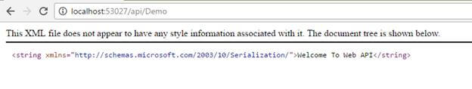

I run http://localhost:53027/api/Demo/1, it will call “Get (int id)”. When there is a parameter in the method, the output looks like below.

Outputs return as XML format.

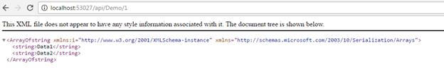

# Project:

EMPLOYEE DATABASE MANAGEMENT SYSTEM (EDMS)

EDMS is a CRUD (Create, Read, Update, Delete) Web Application consist of Three parts

So one can operate on sorted Data in a system for the use by Authorities and HR Department to know the details of Employee in order to keep their records and use them further using React JS for front end, ASP dot net Web API for backend and microsoft SQL server for the database.  
Also, added navigation menu with routing in react, display data in bootstrap table, add modal pop up window with dropdowns and date pickers. Also learn how to upload photo and store it in the backend server.

This project focuses on the office / employees.

### **Prerequisites**

* Install .NET Core 2.0.0 or above SDK from [here](https://www.microsoft.com/net/core#windowscmd).
* Install the latest version of Visual Studio 2017 Community Edition from [here](https://www.visualstudio.com/downloads/).
* Download and install the latest version of Node.js from [here](https://nodejs.org/en/download/).
* SQL Server 2008 or above.

#### OTHER FEATURES :

* Secure Database
* All Data Save / Edit / Delete
* Refresh System
* Easy to Use

### **Creating the Tables**

Using Microsoft SQL Server Management Studio I Created Database EmployeeDB with Table Department and Employee

Format of Database is :

|  |  |
| --- | --- |
| Department ID | Department Name |

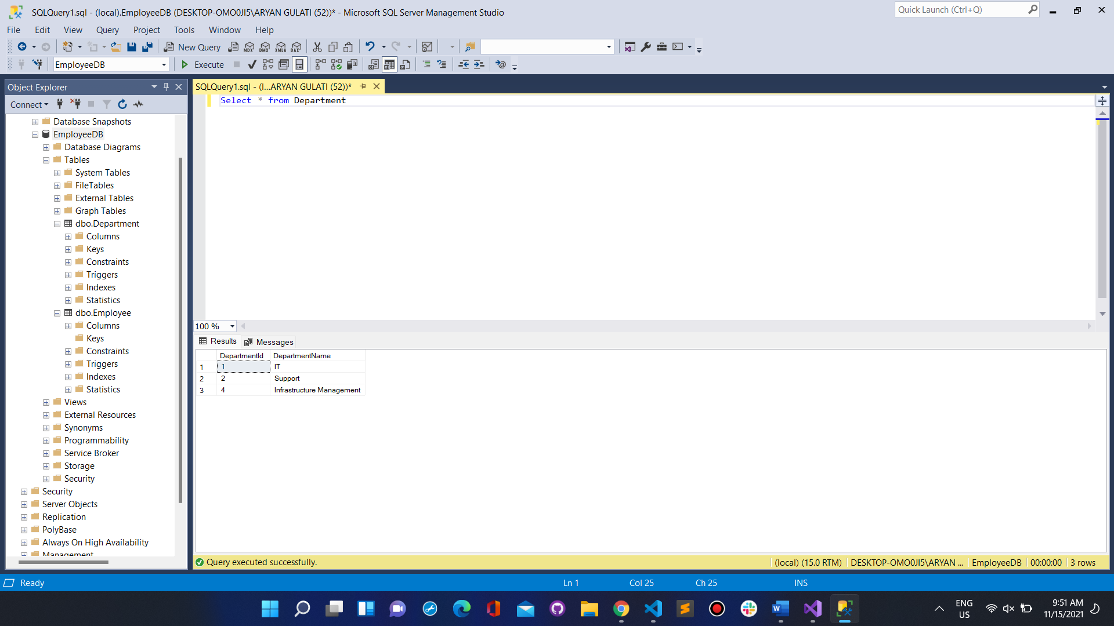

Queries Used :

create table dbo.Department(DepartmentId int identity(1,1),DepartmentName Varchar(500))

select * from dbo.Department

insert into dbo.Department values(‘IT’)

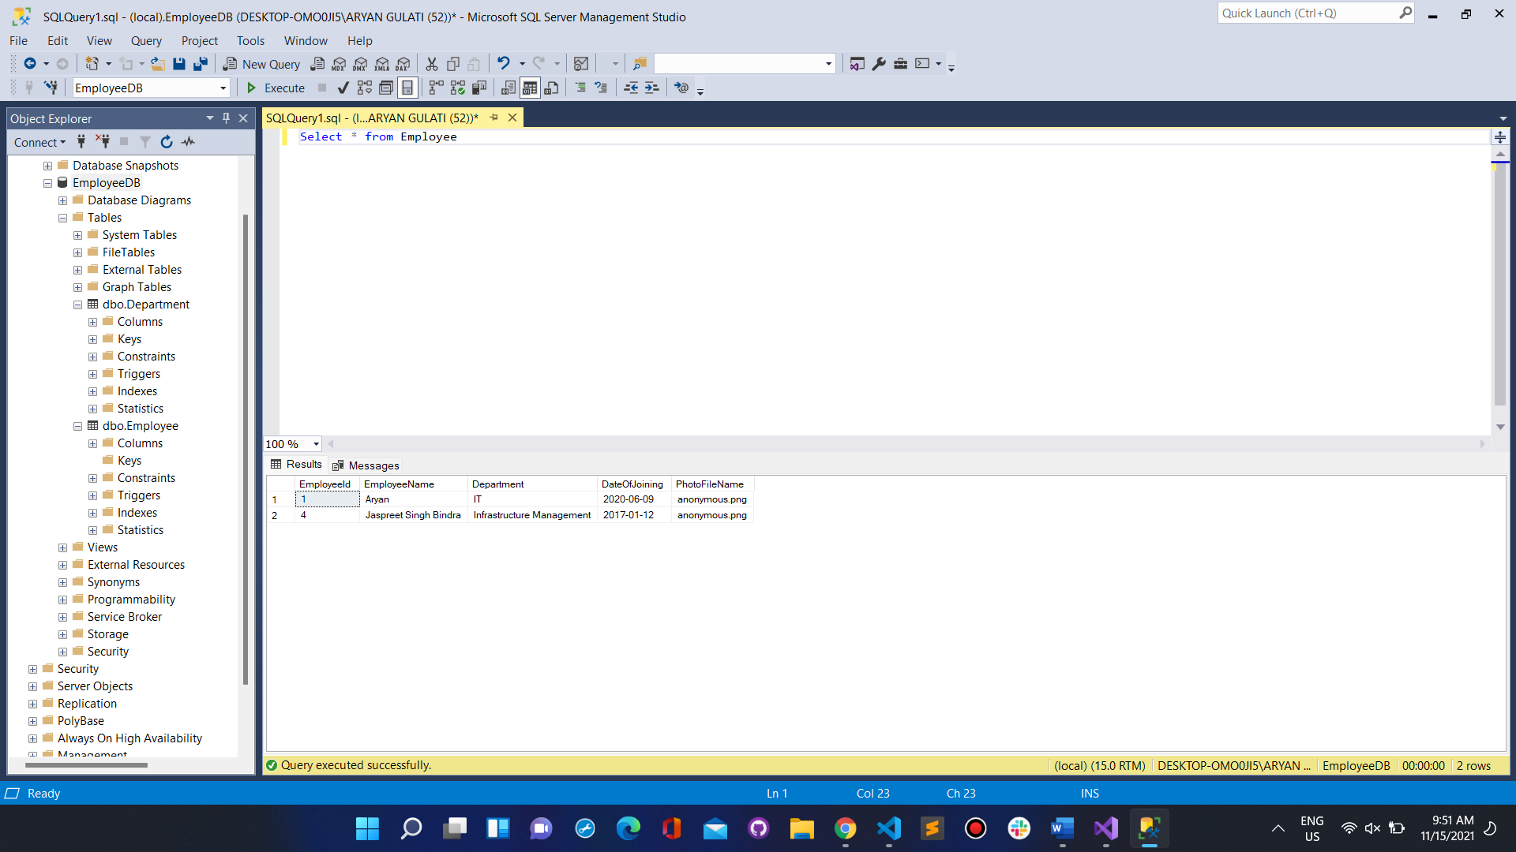

|  |  |  |  |  |
| --- | --- | --- | --- | --- |
| Employee ID | Employee Name | Department | Date of Joining | Options |

Queries Used :

create table dbo.Employee(

EmployeeId int identity (1,1),

EmployeeName varchar(500),

Department varchar(500),

DateOf Joining date,

PhotoFileName varchar(500)

insert into dbo.Employee values ("Sam', 'IT', '2020-06-01, anonymous.png")

select * from dbo.Employee

### **Create an MVC Web Application**

Open Visual Studio and select File >> New >> Project. After selecting the project, a "New Project" dialog will open. Select .NET Core API inside the Visual C# menu from the left panel.

When project will be created. You can observe the folder structure in Solution Explorer as shown in the below image.

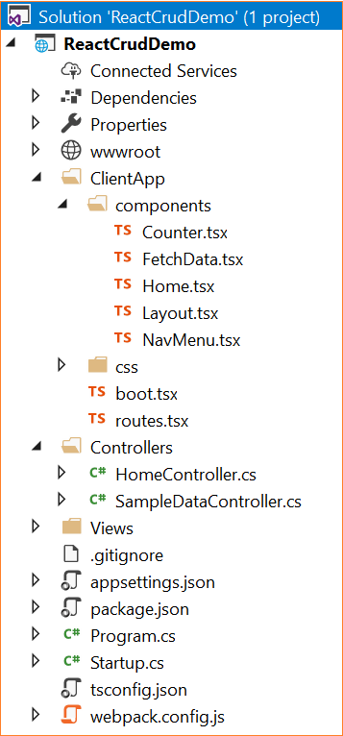

Here, we have our *Controllers* and *Views* folders. We won't be touching the *Views* folders for this tutorial since we will be using React.js to handle the UI. The *Controllers* folders will contain our Web API controller. The point of interest for us is the ClientApp folder where the client side of our application resides. Inside the *ClientApp/components* folder, we already have a few components created which are provided by default with the React.js template in VS 2017. These components will not affect our application, but for the sake of this tutorial, we will delete the *fetchdata.tsx* and *counter.tsx*files from *ClientApp/app/components.*

### **Adding the Model to the Application**

We are using the Entity Framework Core database first approach to create our models. Navigate to Tools >> NuGet Package Manager >> Package Manager Console.

We have to install the package for the database provider that we are targeting, which is SQL Server in this case. Hence, run the following command:

1

Install-Package Microsoft.EntityFrameworkCore.SqlServer

Since we are using Entity Framework Tools to create a model from the existing database, we will install the tools package as well. Hence, run the following command:

1

Install-Package Microsoft.EntityFrameworkCore.Tools

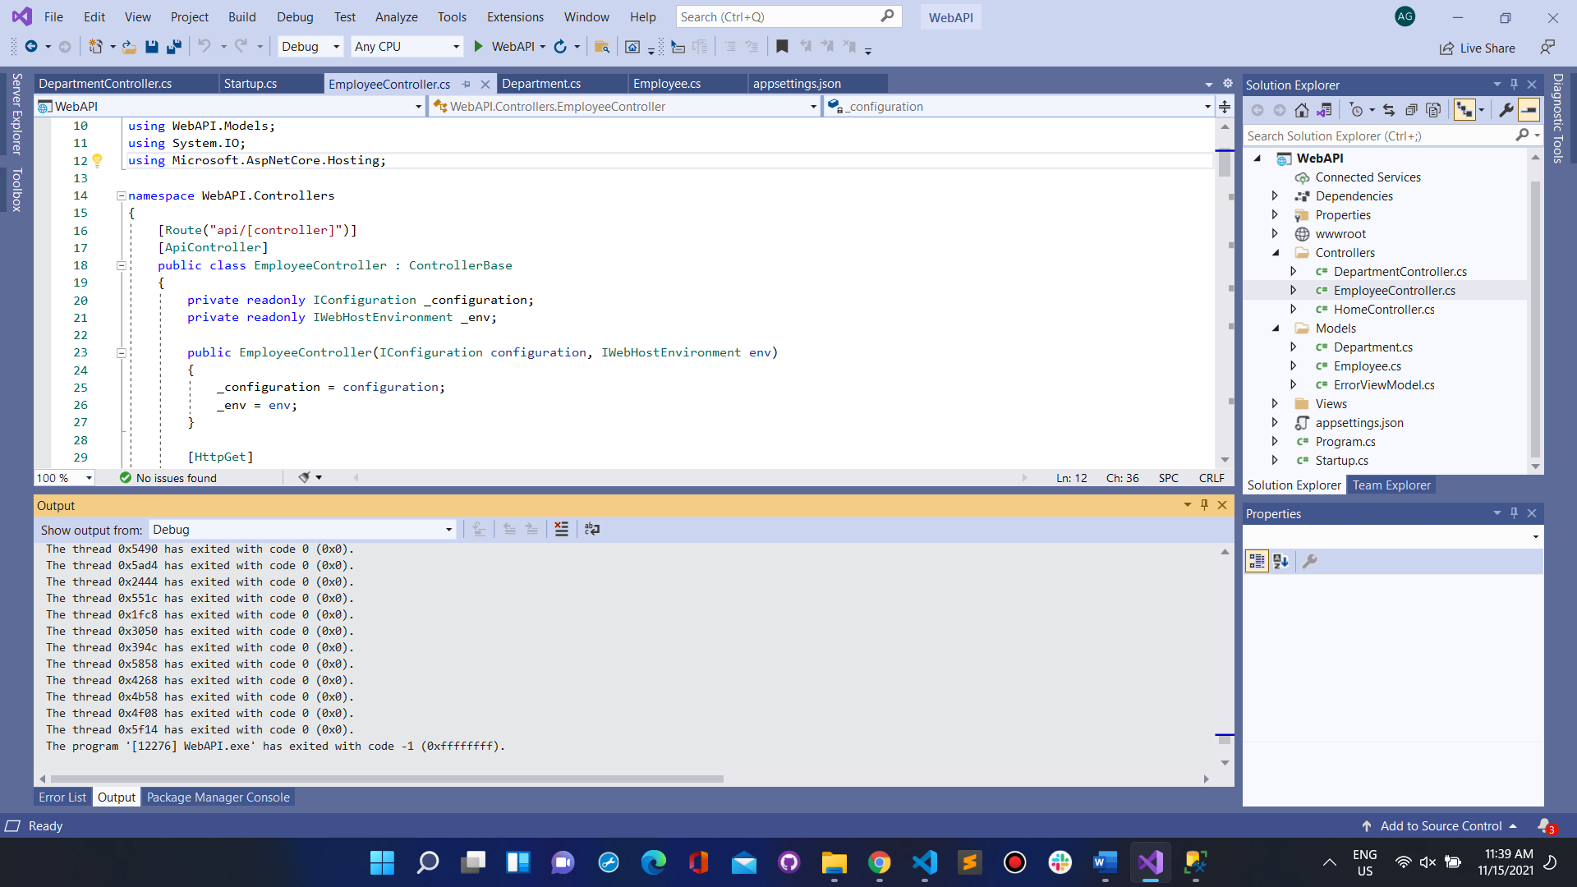

Adding Controllers and Modals also updating Startup.cs

* EmployeeController.cs
* DepartmentController.cs
* Department.cs
* Employee.cs

### **Frontend of Website using ReactJS :**

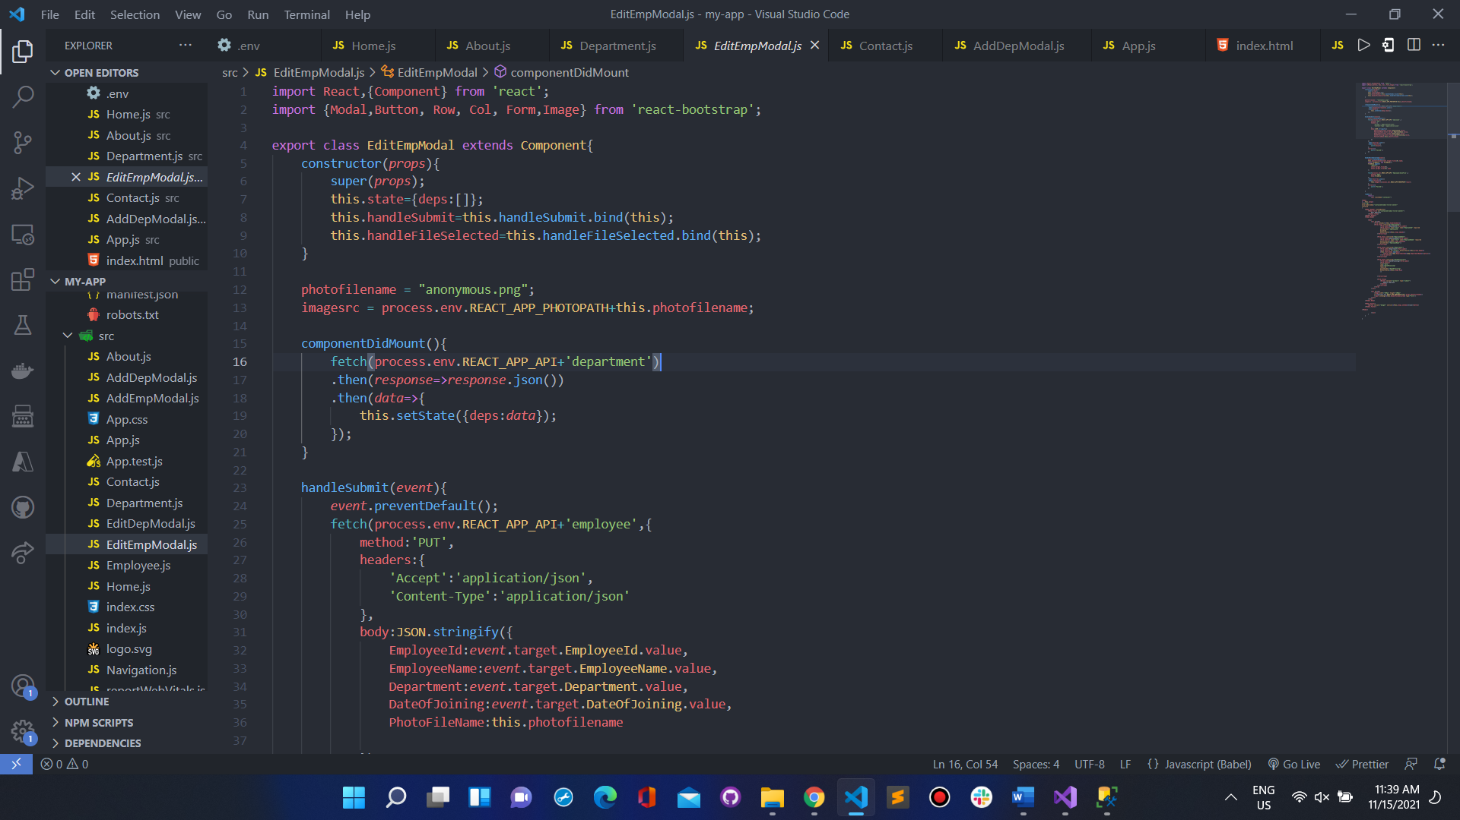

Code can be found at: [EDMS](https://github.com/aditi-gulati/Employee-Database-Management-System/tree/main)

# WORKING :

Database Earlier:





OPERATIONS ON DEPARTMENT AND EMPLOYEE PAGE

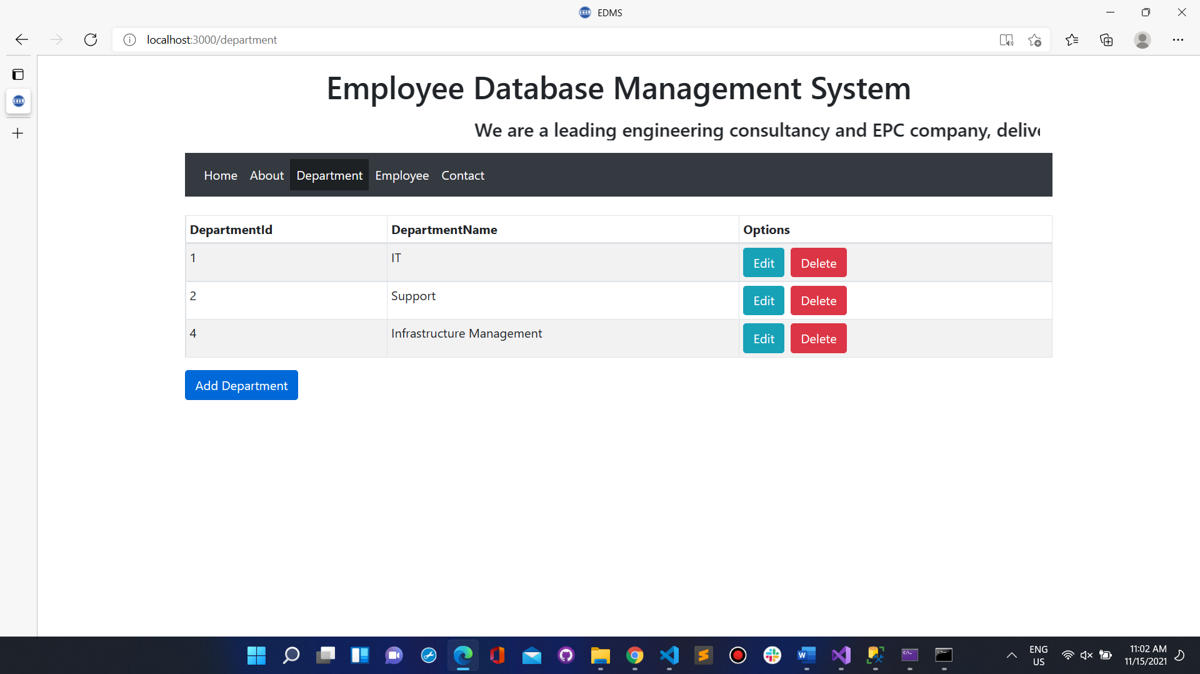

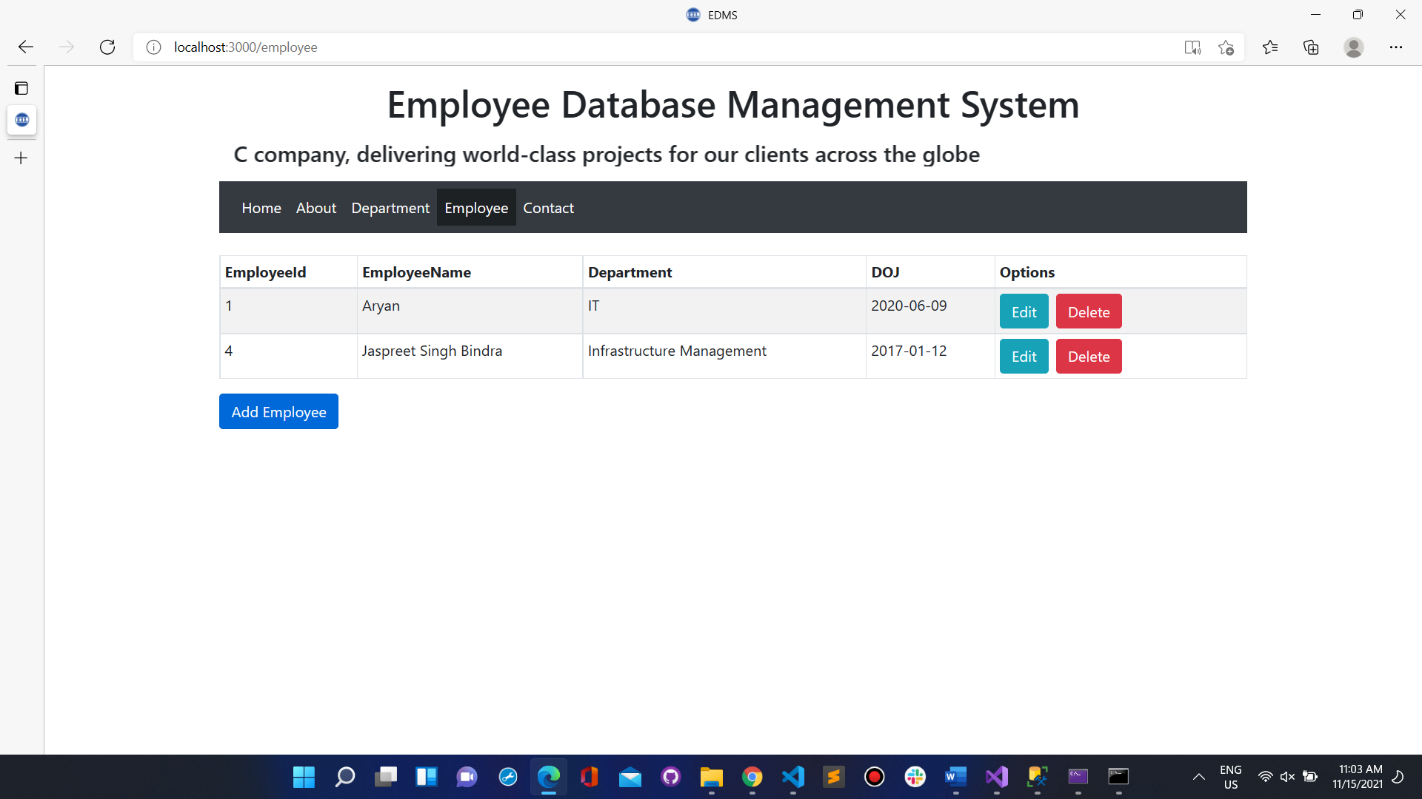

UPDATING DEPARTMENT

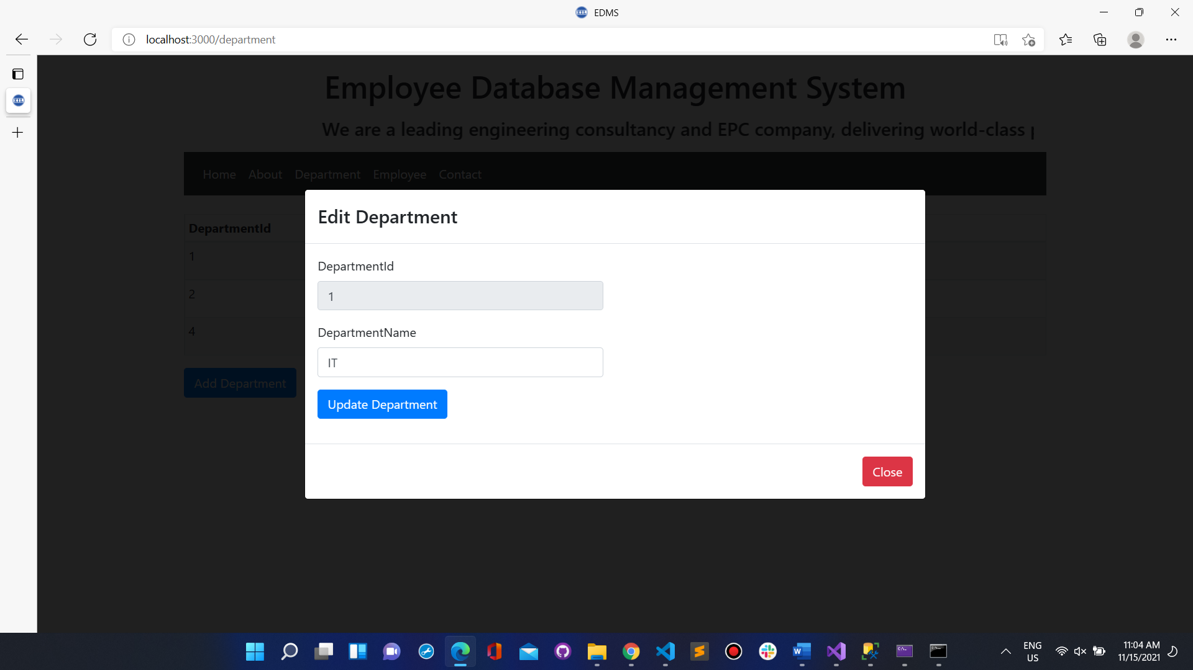

ADDING DEPARTMENT

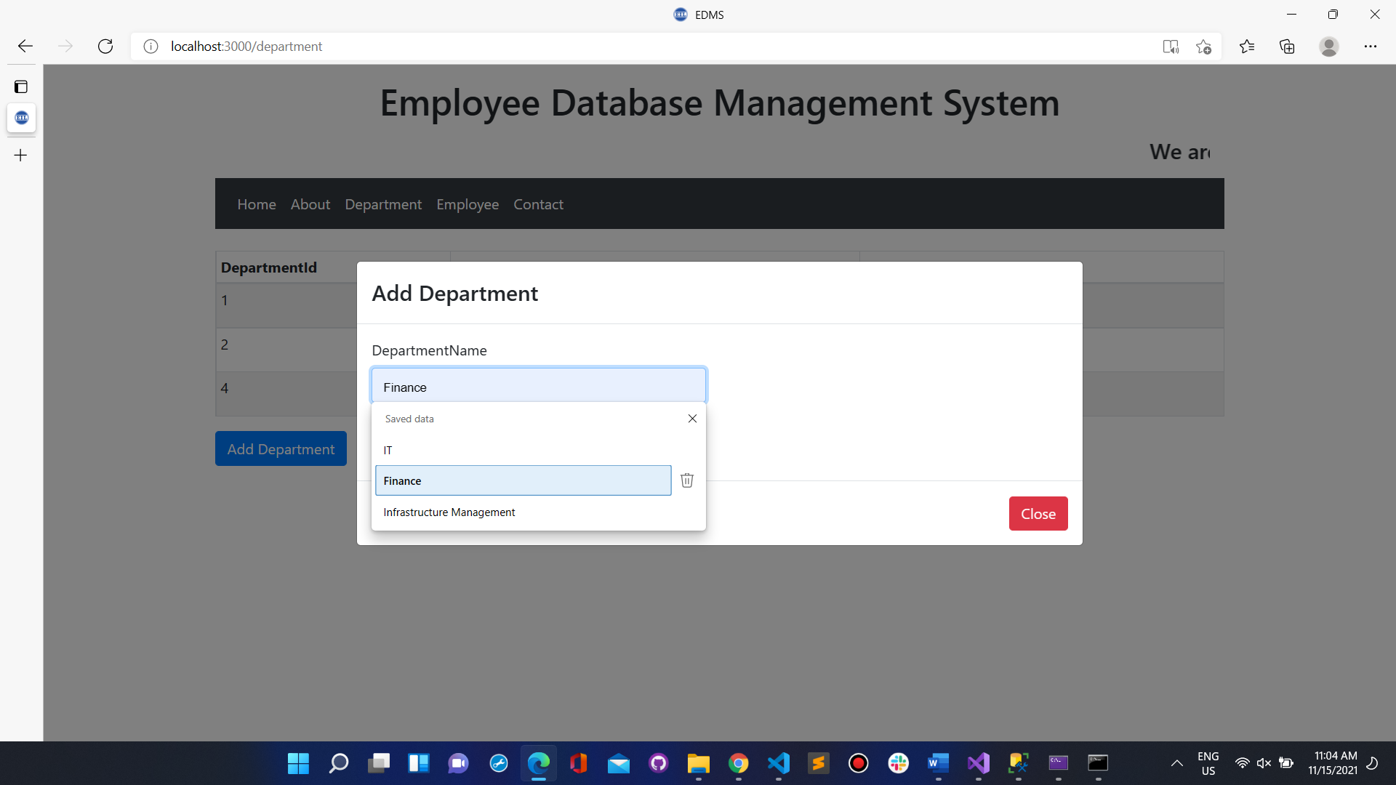

DEPARTMENT ADDED SUCCESSFULLY

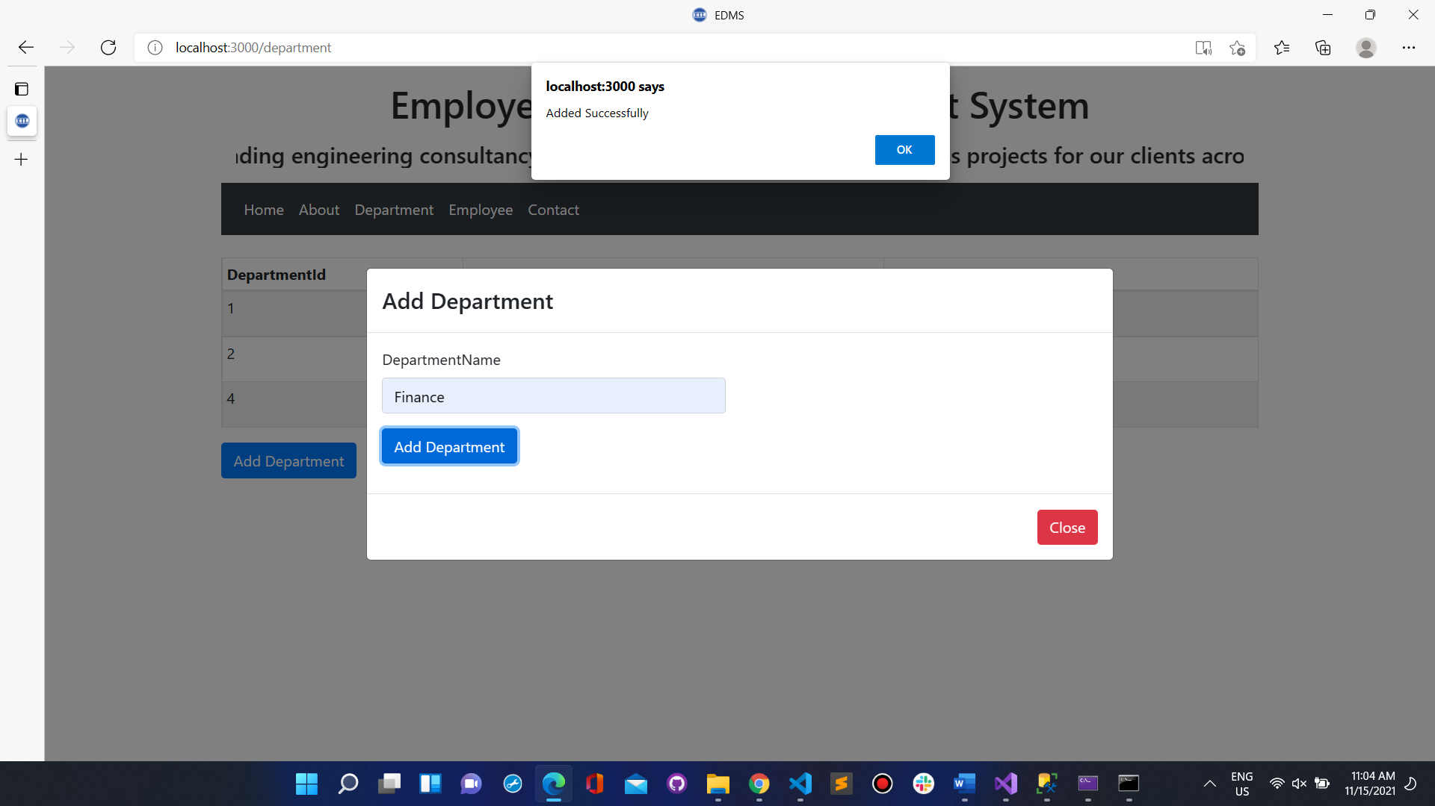

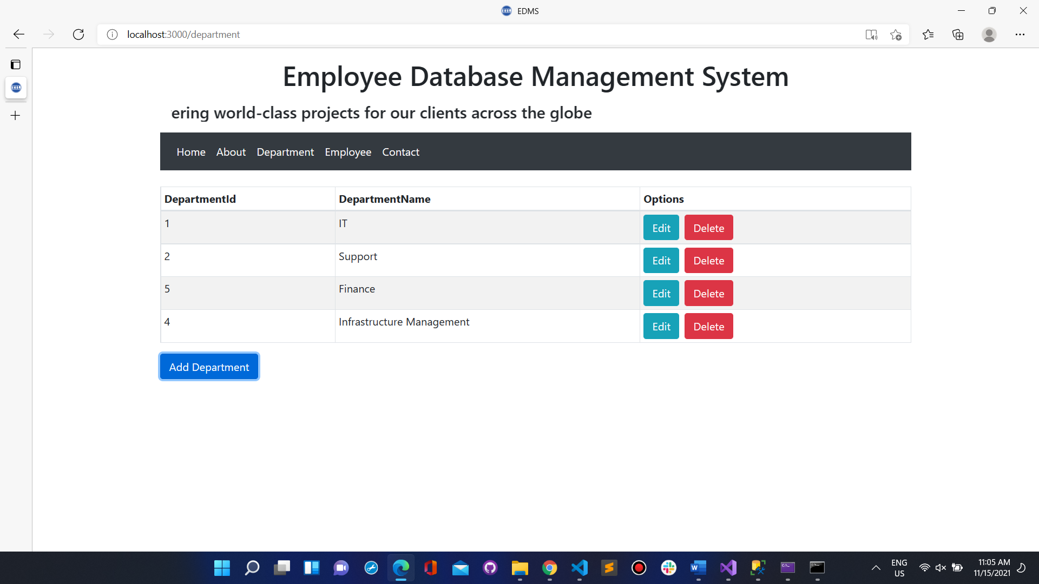

DELETING DEPARTMENT

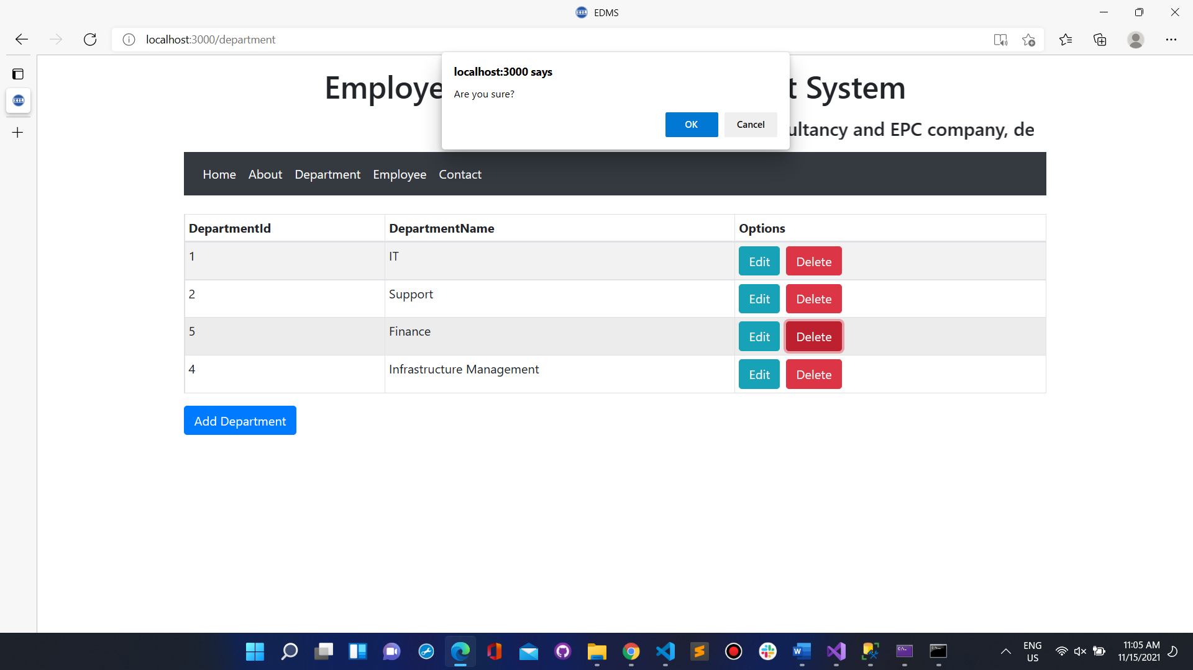

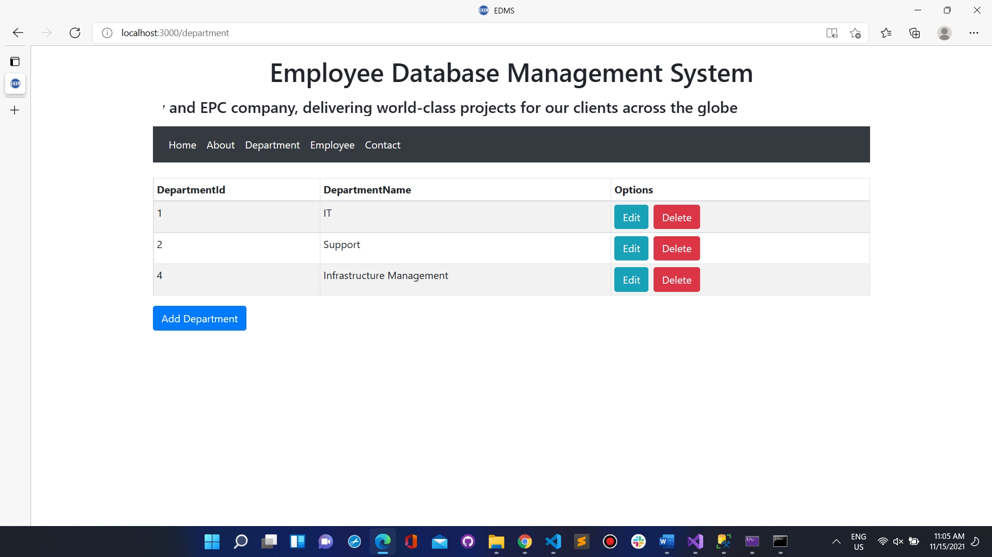

ADDING AND UPDATING EMPLOYEES



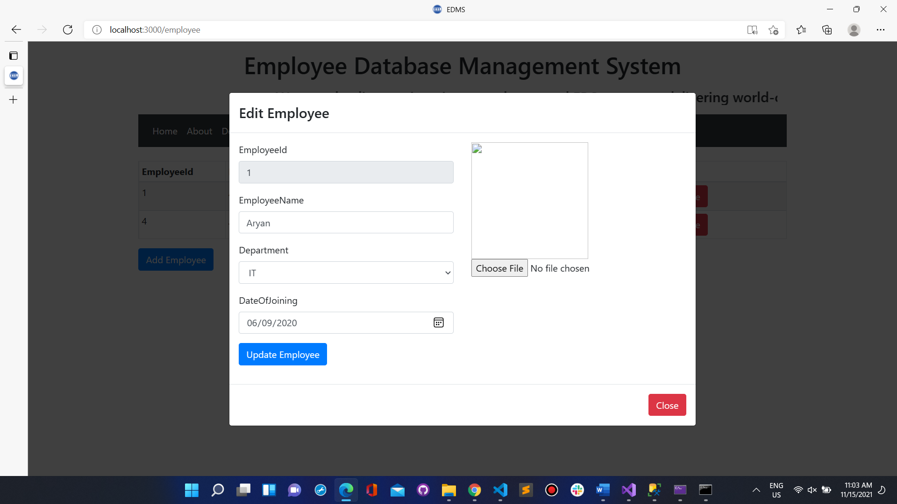

ADDING EMPLOYEE

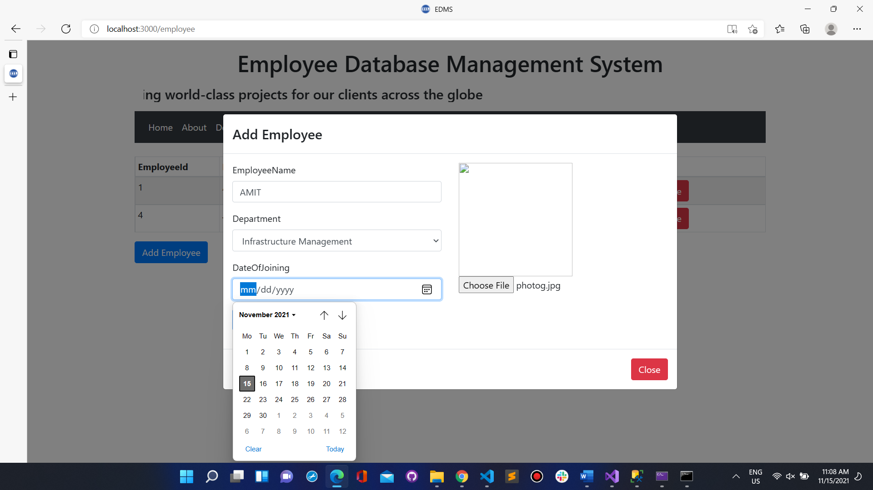

EMPLOYEE ADDED SUCCESSFULLY

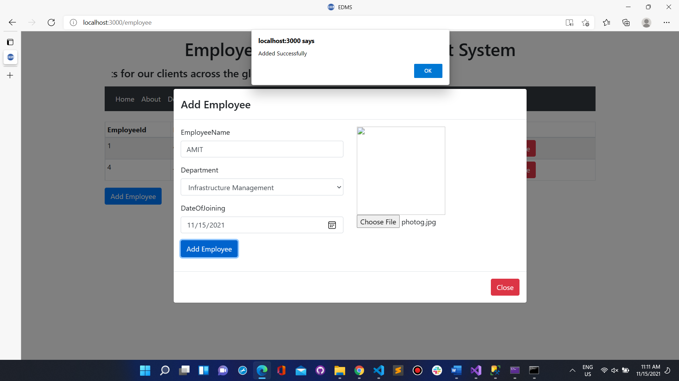

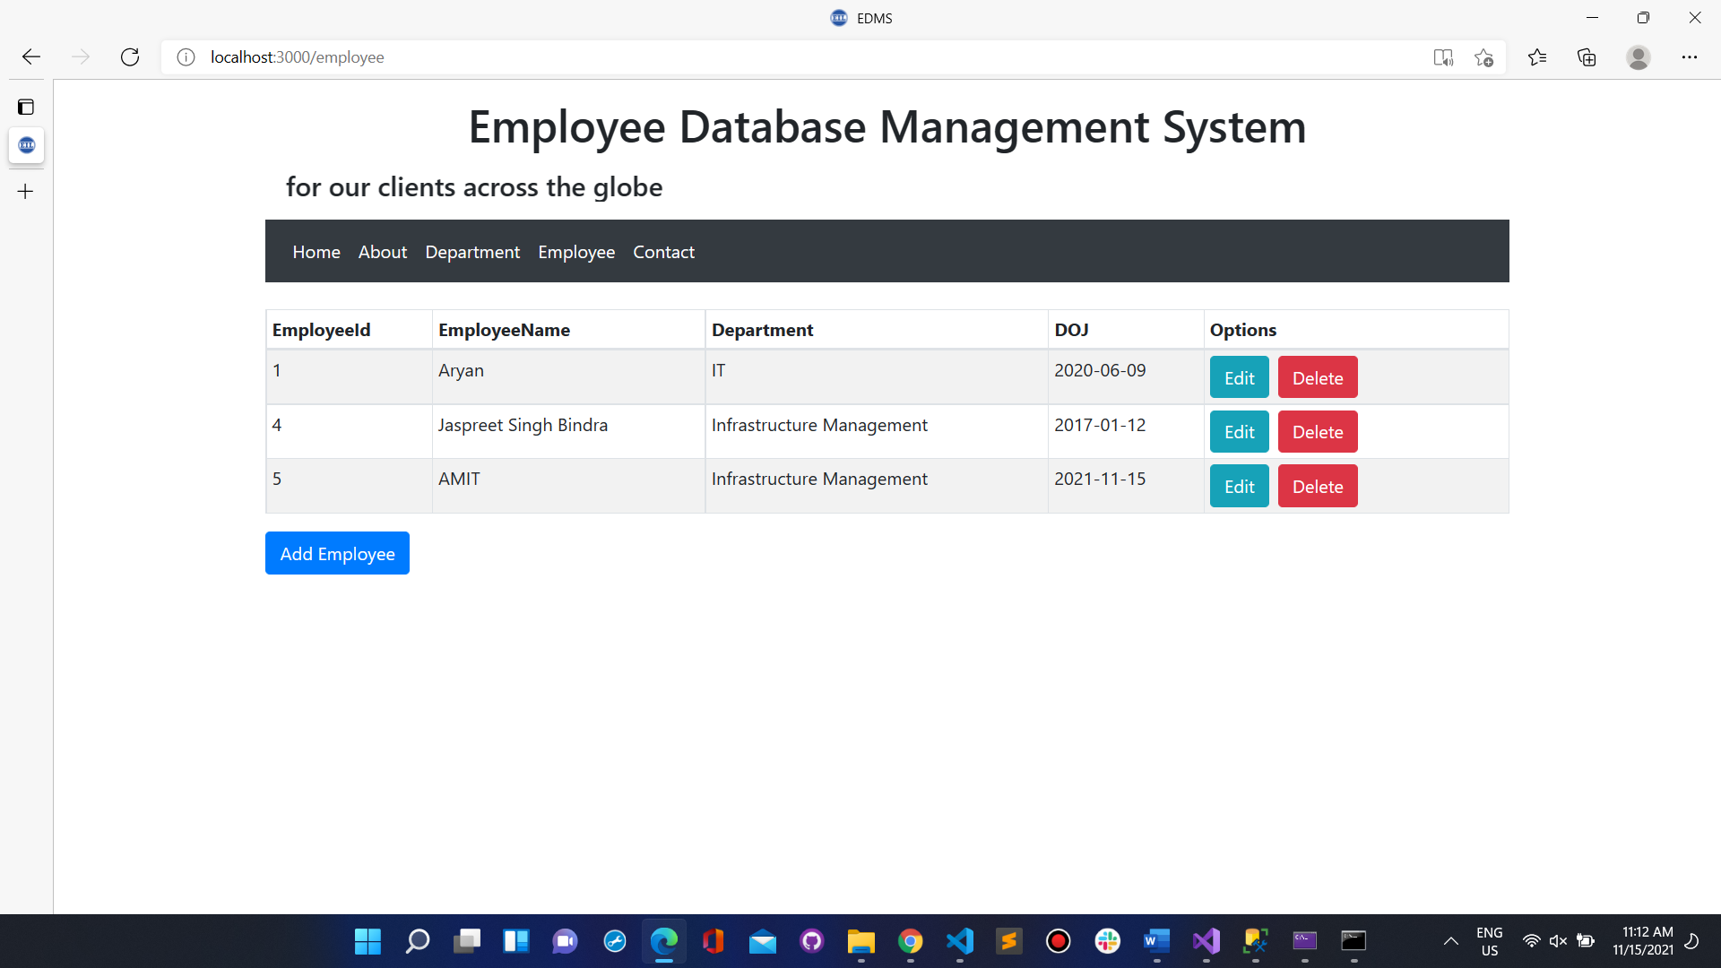

ALSO DATA GET UPDATED IN DATABASE ON VARIOUS OPERATIONS

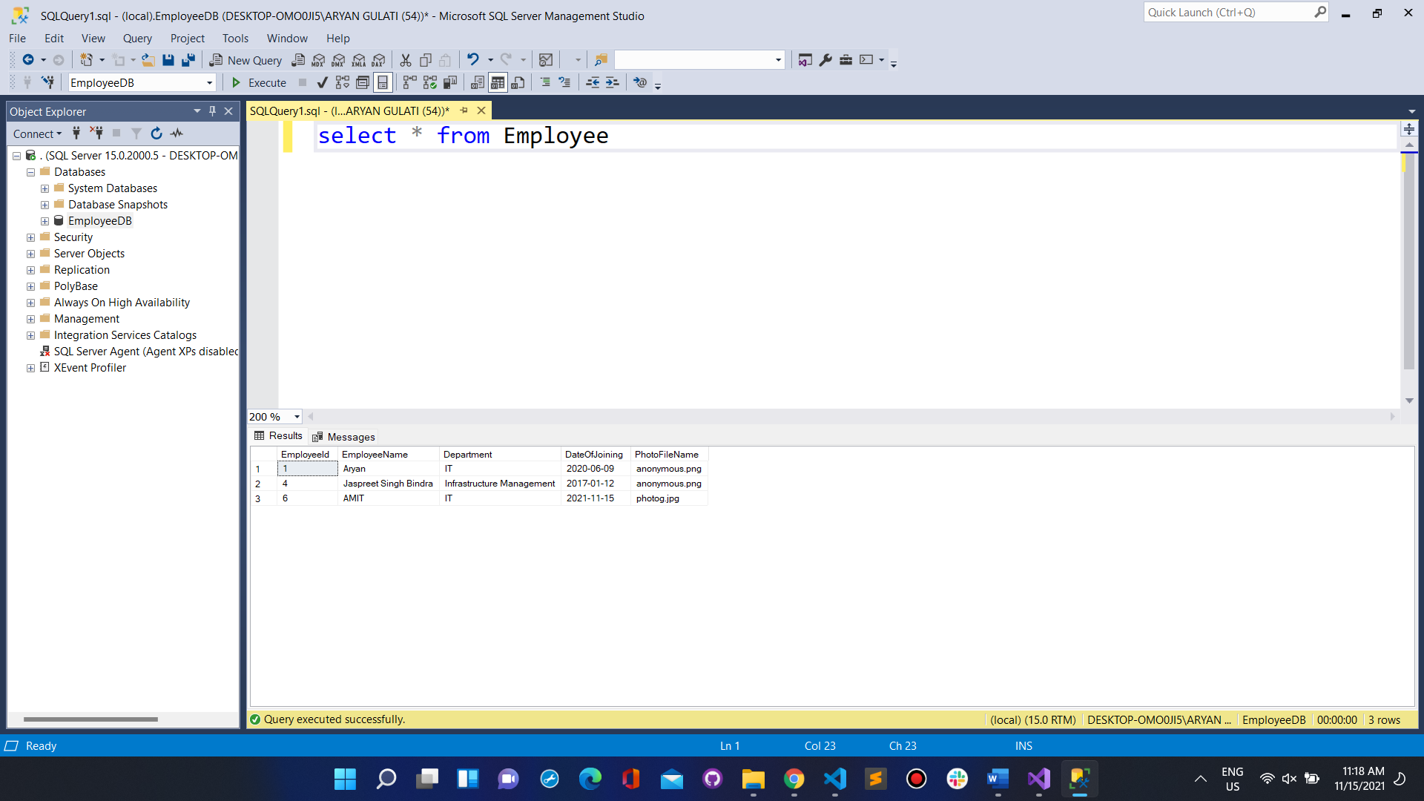

DELETING EMPLOYEE

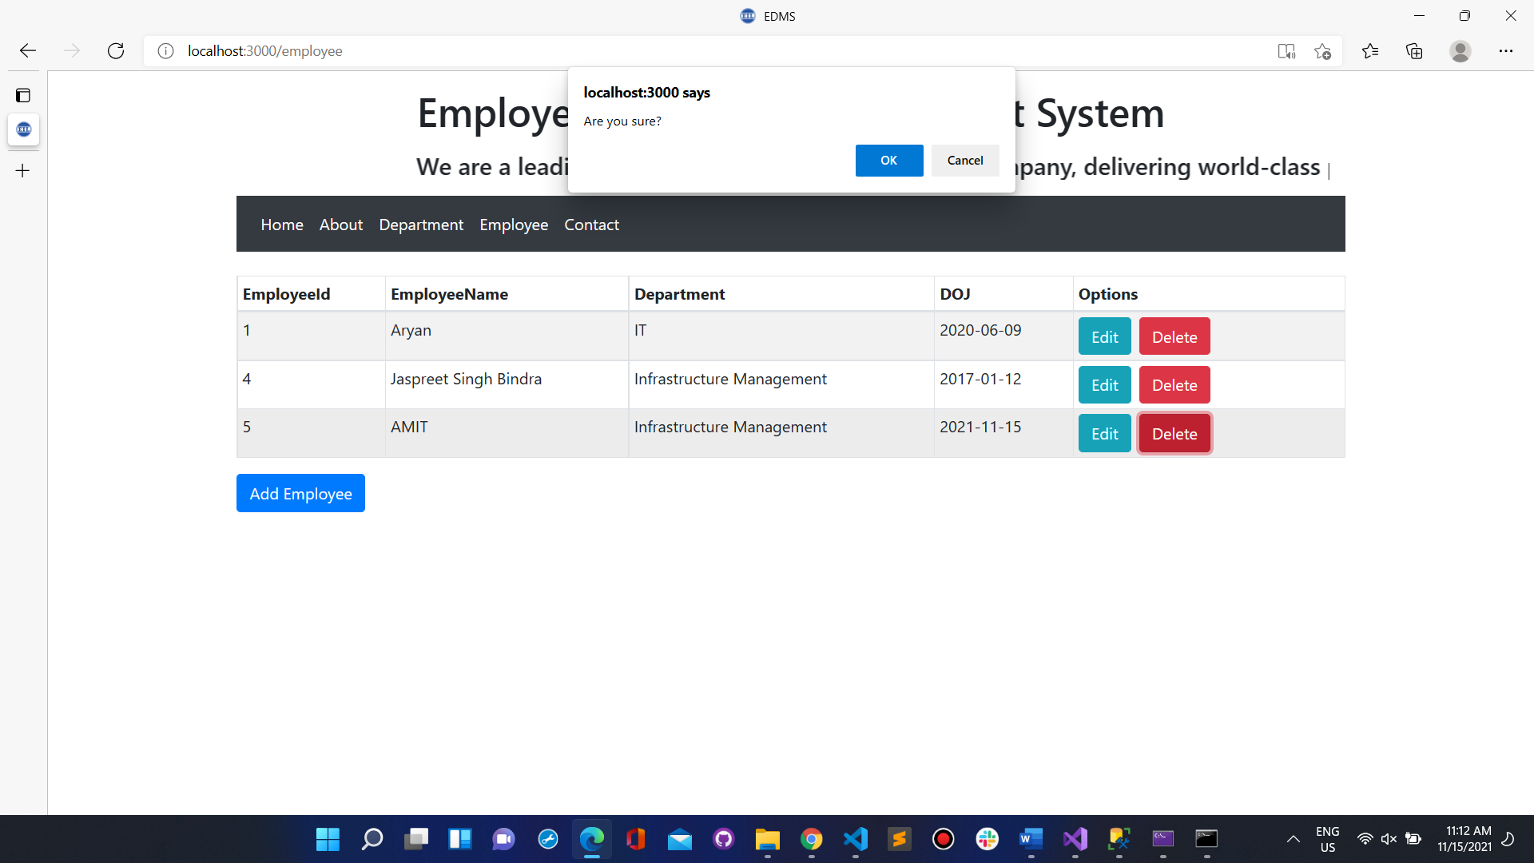

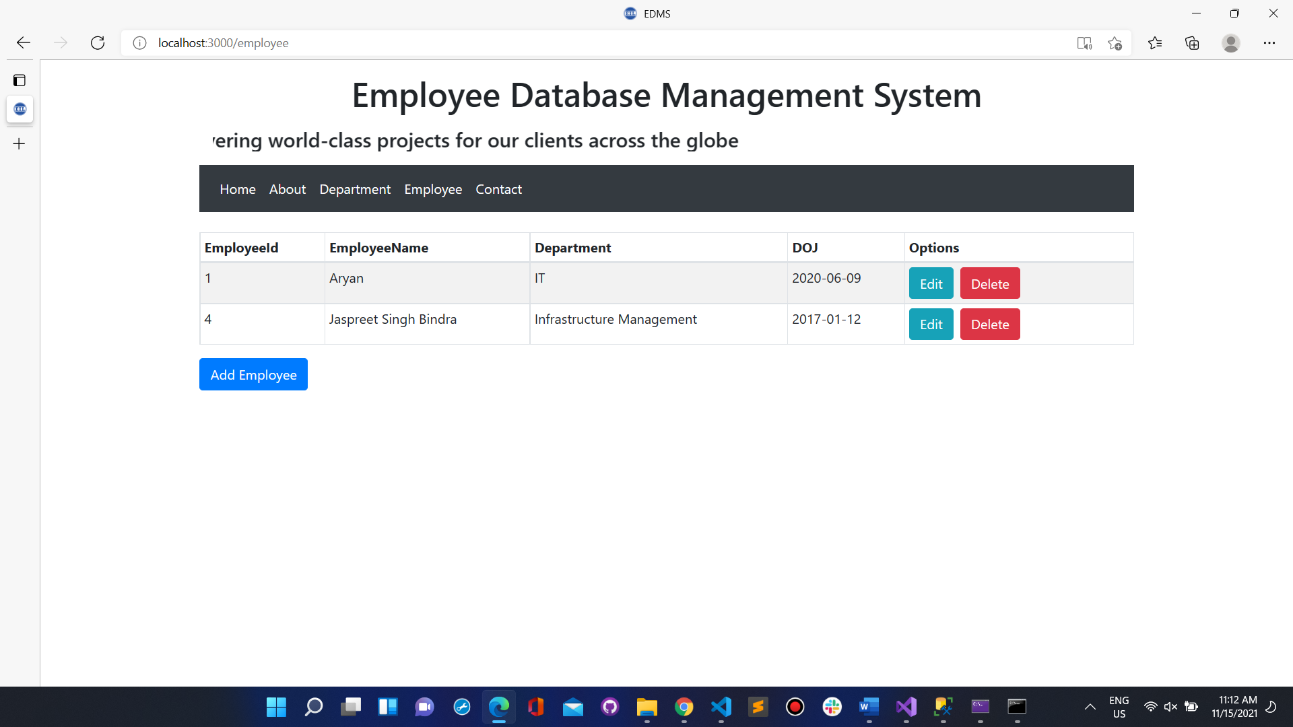

# SAMPLE WEBSITE:

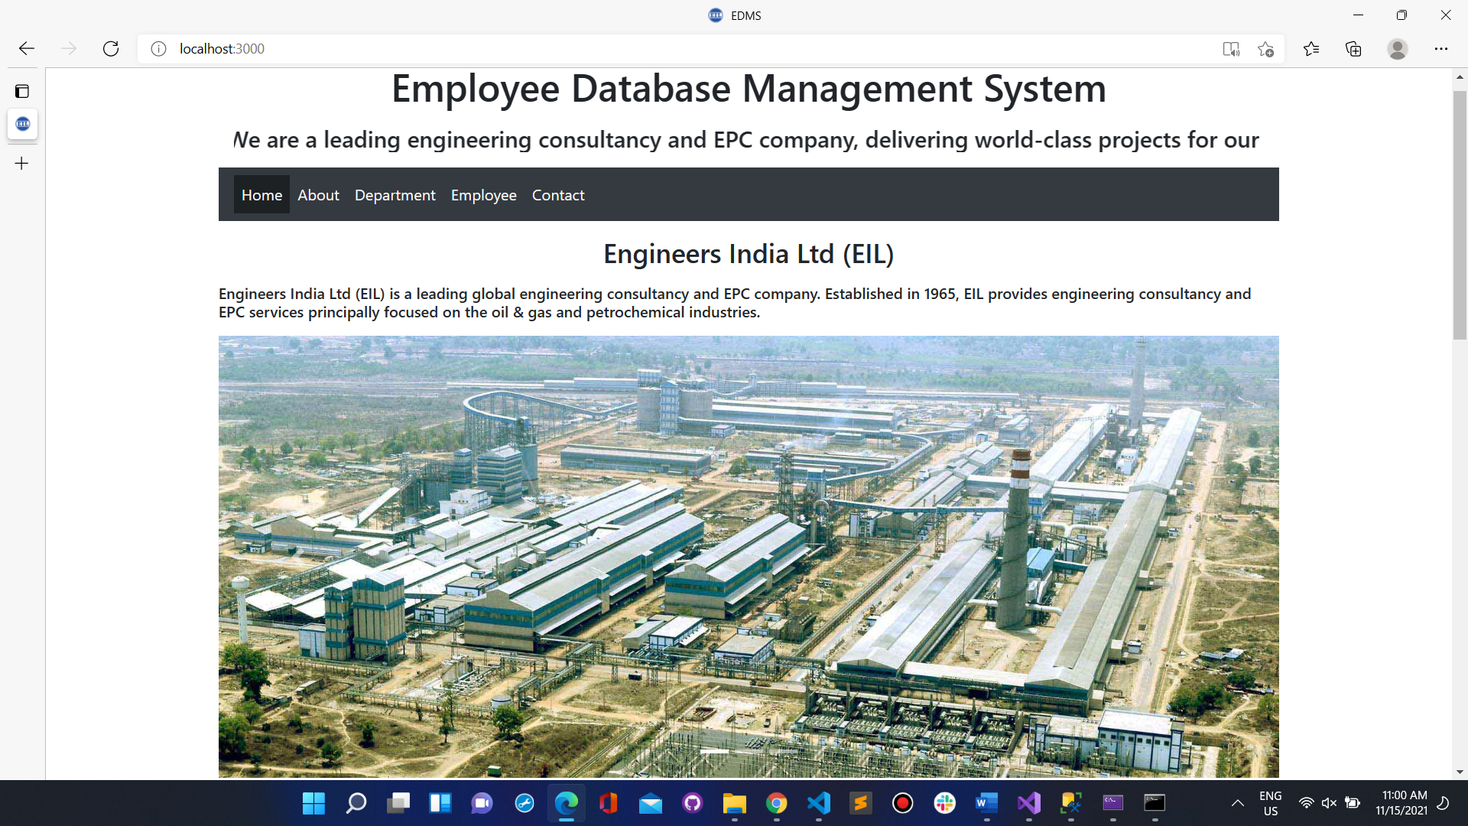

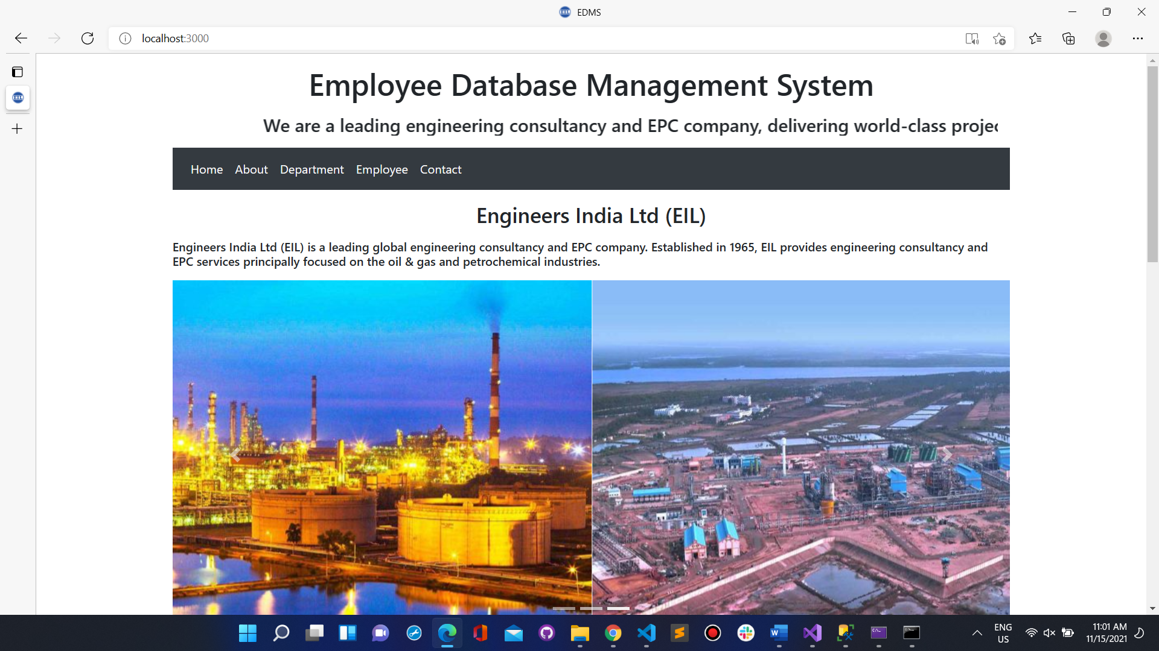

HOME PAGE

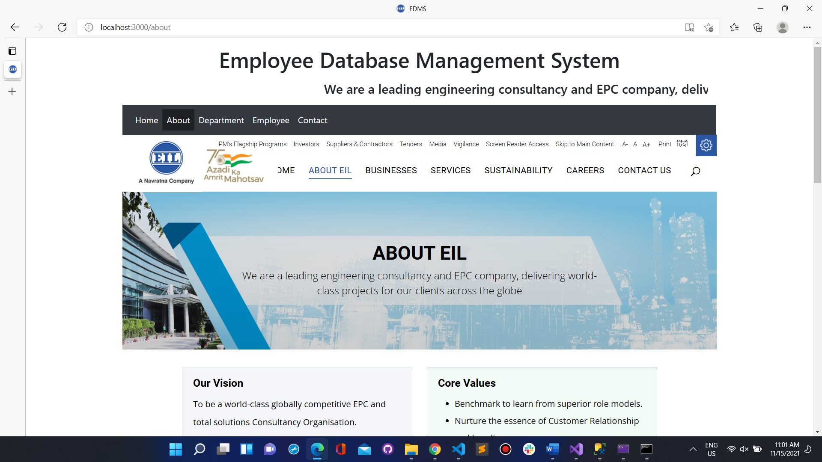



ABOUT AND CONTACT PAGE





DEPARTMENT AND EMPLOYEE PAGE

Future Scope:

* Deployment of WebApp on some CloudPlatform like AWS, Heroku, etc.
* Also Making Some documentation for Code
* Also adding More Employee Details in Database
* We can use ML to create a Record of all employees and marking attendance with face recognition mark in database and give monthly report about employee

References:

* https://www.tutorialspoint.com
* https://www.w3schools.com
* https://docs.microsoft.com
* https://www.en.wikipedia.org
* https://www.stackoverflow.com
* <https://www.javaspoint.com>
* <https://www.geeksforgeeks.org/>
* <https://docs.microsoft.com/en-us/aspnet/web-api/overview/getting-started-with-aspnet-web-api/tutorial-your-first-web-api>